Supplementary material: Which Bubble Sort Should Bubble Inc. Ship? A Running-Time Experiment
Pavlo Harabadzhiiev and Vladyslav Nechaiev
Experiment 1, Experimentation & Evaluation 2026 · Università della Svizzera italiana
This is the extended version of the report (all follow-up experiments, all five-number tables, the experiments on other computers). The submitted report is the shorter file “Experiment 01 - Report.docx”, which cites this file as S-… (S-C = Appendix C, and so on).

Abstract
Bubble Inc. must choose one of three Java bubble-sort implementations, judged only by running time. We ran a pre-registered, full-factorial experiment: three algorithms, six input orders and six sizes (100 to 20 000 elements), ten fresh JVMs per condition, identical data for all algorithms. Two of six hypotheses were supported and four falsified, notably because WhileNeeded was 7–12 % slower than PassPerItem on reversed input, an effect that other JDKs and computers did not reproduce. A steady-state re-measurement, prompted by a review of the raw data, left the verdicts unchanged. In it, WhileNeeded is fastest in 25 of 30 conditions and within 16 % of the best; PassPerItem is up to 40 000 times slower. The pre-registered criterion was not met, so we recommend WhileNeeded on a post-hoc criterion.

1. Introduction
Bubble sort is the textbook example of a simple but slow sorting algorithm, yet it is still shipped in teaching libraries, embedded code and small utilities because it is short, stable and sorts in place. The company Bubble Inc. wants to ship one bubble-sort implementation in its Java library. Three candidates exist. They are all correct and differ only in when they stop: PassPerItem always makes n passes over the array, UntilNoChange stops after the first pass in which nothing was swapped, and WhileNeeded also stops early and, in addition, shortens every pass to the position of the last swap of the previous pass. Reading the code suggests an ordering (WhileNeeded ≤ UntilNoChange ≤ PassPerItem in the number of comparisons), but running time on a real JVM also depends on branch prediction, memory access and the just-in-time (JIT) compiler. The customer-facing question – which implementation is fastest? – therefore needs measurements, not only code reading. A wrong choice can be expensive: when the input is already sorted, an implementation that never stops early is thousands of times slower than one that does.
The only decision criterion is running time. We designed a controlled, full-factorial experiment: the three algorithms sort identical data in six input orders and six sizes (100 to 20 000 elements), each condition in 10 fresh JVMs after a warm-up, with the hypotheses committed to git before any measurement. Follow-up experiments (appendices) test whether the recommendation survives other garbage collectors, Java versions, element types, tiny arrays, cold starts, another benchmark harness (JMH) and other computers.

Hypotheses
The hypotheses below were committed to the repository (file HYPOTHESES.md, commit 7e056c2, 2026-11-04 01:16:35 local time) before the benchmark harness was committed and before any main-experiment data was collected; a first, uncommitted version of the harness was used for a short pilot a minute later (Section 2.4). The times are local git commit times; the repository was first pushed to GitHub, at about 02:44, after the main run. Table 1 restates them with the null hypothesis written out; the conditions and thresholds are exactly those of HYPOTHESES.md, which has only one commit and was never edited. In all of them the independent variables are algorithm, input order and input size n (as named per hypothesis), and the dependent variable is the running time of one call to sort (nanoseconds, ratio scale). "Median time" always means the median over the medians of the 10 JVM forks of a condition.
Table 1. Pre-registered hypotheses. Each is falsifiable: it names a numeric threshold, and a condition whose 95 % confidence interval lies entirely on the wrong side of that threshold counts as a falsification. Under the rule registered in HYPOTHESES.md a single clear violation falsifies a hypothesis.
Hypothesis | Statement (alternative hypothesis) | Null hypothesis / variables
H1 (sorted input) | For n ≥ 1 000, on sorted input the median time of PassPerItem is at least 100× that of UntilNoChange and at least 100× that of WhileNeeded. | H0: the ratio is below 100 for at least one of the two comparisons. IV: algorithm; DV: running time.
H2 (random input) | For n ≥ 5 000, on random input WhileNeeded has the lowest median running time of the three algorithms, while UntilNoChange and PassPerItem differ from each other by less than 15 %. | H0: WhileNeeded is not the fastest, or UntilNoChange and PassPerItem differ by 15 % or more. IV: algorithm; DV: running time.
H3 (reversed input) | For n ≥ 5 000, on reversed input WhileNeeded is at least 10 % faster than both UntilNoChange and PassPerItem. | H0: WhileNeeded is less than 10 % faster than at least one of them. IV: algorithm; DV: running time.
H4 (locally disturbed input) | For n ≥ 5 000, on nearly sorted input with local swaps, both UntilNoChange and WhileNeeded are at least 10× faster than PassPerItem. | H0: at least one of the two is less than 10× faster. IV: algorithm; DV: running time.
H5 (growth with n) | On random input, doubling n from 10 000 to 20 000 multiplies the median time of every algorithm by a factor between 3.3 and 4.7 (quadratic growth). On sorted input the factor is below 2.6 for UntilNoChange and WhileNeeded (linear growth) and between 3.3 and 4.7 for PassPerItem. | H0: at least one factor lies outside the stated range. IV: input size and algorithm; DV: running time.
H6 (recommendation) | In no combination of input order and size n ≥ 1 000 is WhileNeeded more than 5 % slower than UntilNoChange or PassPerItem. If this holds, WhileNeeded is recommended. | H0: in at least one such combination WhileNeeded is more than 5 % slower than another algorithm. IV: algorithm, input order, input size; DV: running time.

2. Method

2.1 Variables
Independent variables (manipulated by us; each level was combined with every level of the other two):
Independent variable | Levels
Algorithm (3) | PassPerItem · UntilNoChange · WhileNeeded (the three provided Java classes, unmodified)
Input order (6) | random · sorted · reversed · nearly sorted with local swaps (5 % of the elements swapped with a neighbour at most 10 positions away) · nearly sorted with random swaps (n/20 random pairs swapped) · few unique values (random draws from 10 values)
Input size n (6) | 100 · 1 000 · 2 000 · 5 000 · 10 000 · 20 000 elements

Dependent variable (what we measure):
Dependent variable | Measurement | Scale
Running time of one call of sort() | Wall-clock time from System.nanoTime(), measured for a batch of consecutive sorts on private copies of the input and divided by the batch size. Copying and the sortedness check are outside the timed region. | Ratio scale, nanoseconds per sort

Control variables (kept constant):
Control variable | Fixed value
Input data | Identical arrays for all three algorithms (same seed for a given order, n and fork; the algorithm is not part of the seed). Elements are boxed Integer objects, allocated in array order (values from −128 to 127 are shared, cached Integer objects, which concerns the few-unique arrays and some of the n = 100 arrays).
Machine and Java | One laptop (Apple M3 Pro), OpenJDK 26.0.1, AC power, lid open, heavy applications closed by the user; JVM flags -Xms2g -Xmx2g -XX:+UseSerialGC.
JIT / JVM state | One algorithm per JVM process, so that the call to compareTo is not influenced by other sorting code; every measurement starts in a fresh JVM, after a warm-up phase.
Garbage collection | Heap pre-sized so that no collection happens during timed batches; each batch is checked for collections and flagged if one occurs.
Run order | All 1 080 JVM runs executed in one session in a random order (fixed seed 20261104), so that slow drifts of the machine are not confounded with an algorithm or a size.

2.2 Design
Type of study (check one): ☐ Observational Study ☐ Quasi-Experiment ☒ Experiment
Number of factors (check one): ☐ Single-Factor Design ☒ Multi-Factor Design ☐ Other
This is a true experiment: we manipulate the independent variables ourselves and assign the conditions without any pre-existing grouping. It is a multi-factor, full-factorial design with three factors (algorithm × input order × input size, 3 × 6 × 6 = 108 conditions, called cells). It is a repeated-measures (within-subjects) design: the "participants" are the random data sets, and the same data set (identified by its fork number) is sorted by all three algorithms, so that comparisons between algorithms are paired and differences between data sets cancel out. In the language of the lectures, the repeated-measures design raises the sensitivity of the comparison, but it brings the risk of order effects (a later measurement is influenced by an earlier one). We control order effects in three ways: every measurement runs in its own fresh JVM, so nothing carries over from one measurement to the next; the order of the 1 080 JVM runs is randomised; and we check for slow drift of the machine afterwards (Section 3.1). Each condition is replicated with 10 independent JVMs (forks) and 30 timed batches per JVM, i.e. 300 observations per cell and 32 400 in total. Because the JVM state is not stable from one fork to the next (JIT decisions can differ), the unit of analysis for inference is the median of one fork, not the individual batch (batches within a JVM are not independent).
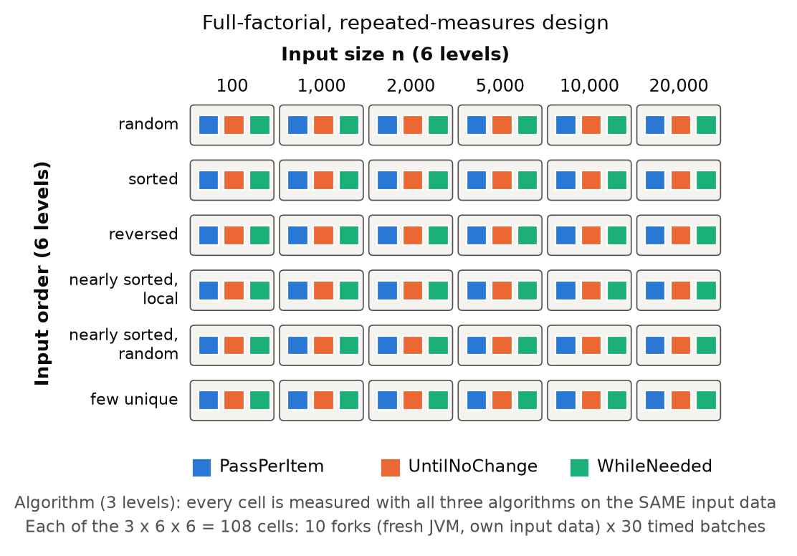
Figure 1. Design of the experiment: three crossed factors (3 × 6 × 6 cells), 10 forks per cell, 30 timed batches per fork; the three algorithms are measured on the same inputs.

2.3 Apparatus and Materials
Hardware and system. Apple MacBook with an Apple M3 Pro (11 cores, 18 GB RAM), macOS 26.7.1 (MacBook Pro, model Mac15,6; the 11 cores are 5 performance and 6 efficiency cores, and macOS does not allow pinning a process to a core), connected to AC power (recorded at the start: battery at 67 % and charging; battery level is a time threat in laptop benchmarks), lid open, screen on, heavy applications closed. We prevented sleep with caffeinate. The full environment record is stored with the data (results/full/environment.txt). Clock frequency and temperature were not recorded.
Software. Main experiment: OpenJDK 26.0.1, Homebrew build (https://formulae.brew.sh/formula/openjdk), with the code compiled by the same JDK. Follow-up runs: Homebrew openjdk@17 (17.0.19) and openjdk@21 (21.0.11), Amazon Corretto 8 (1.8.0_482, https://aws.amazon.com/corretto), Eclipse Temurin 25.0.5 and, on the desktop, Temurin 17.0.21 and 26.0.2.1 (https://adoptium.net); JMH 1.37 (https://github.com/openjdk/jmh) built with Maven. Analysis: Python 3 with pandas 3.1.1 (3.1.0 in the first author's environment, which gives the same outputs), NumPy 2.5.4, SciPy 1.18.1, matplotlib 3.11.2 and python-docx 1.2.0 (pinned in requirements.txt). The three sorting classes and the interface Sorter come from the assignment and were not modified (byte-identical copies in src/exp01). Our own code: InputGenerator (deterministic data), Worker (the measuring program; SteadyWorker is a variant with a longer warm-up of the batch loop, used in Section 3.7), run_experiment.py (orchestrator, one JVM per job), and the analysis scripts. All code and data are public: https://github.com/vaizan4ikys/bubble-sort-benchmark.
How time is measured. Inside the JVM with System.nanoTime(). Sorting an array of 100 elements takes only microseconds, which is too short to time one call reliably. We therefore time a batch of sorts and divide: the batch size is calibrated so that a batch lasts about 2 ms (between 1 and 20 000 sorts per batch). The arrays of a batch are private copies created before the timer starts.

2.4 Procedure
One experimental run (a job) is one JVM process for one (algorithm, order, size, fork) combination:
- The orchestrator starts a fresh JVM (java -Xms2g -Xmx2g -XX:+UseSerialGC exp01.Worker …). The worker generates the input array from (order, n, seed, fork) and creates the one sorter under test.
- Warm-up. The worker sorts fresh copies of the input until at least 20 sorts and 1.5 s have passed and the median of the five most recent sorts is within 5 % of the five before (i.e. the JIT compiler has settled), with a limit of 40 s. For very short sorts (< 100 µs) the time criterion alone ends the warm-up.
- Calibration. From the warm-up speed, the batch size is chosen so that one batch lasts about 2 ms.
- Measurement. Two untimed batches, then 30 times: create the batch of array copies (not timed); start the clock; sort all arrays; stop the clock; check (not timed) that each array is sorted; note whether a garbage collection happened in the timed region. The job is aborted with an error if any result is not sorted.
- The worker prints one CSV line per batch. The orchestrator appends them to raw.csv, runs the 1 080 jobs in randomised order (seed 20261104) and can resume after an interruption.
The whole main experiment took 77 minutes (01:25–02:43 on 4 November 2026). It was started and supervised by the AI assistant (Claude Code) on the first author's laptop, at the first author's request, after the first author had closed other heavy applications. While it ran, the assistant made four short git commits (01:30–01:42, among them the follow-up scripts and the re-measurement rule) and a few low-priority smoke tests, all listed in results/full/interference_log.txt; the 39 jobs that overlapped with them (approximate windows) have a median relative time of 1.002, the other jobs 1.000 (Section 3.1). Because the same ten fork numbers (0–9) are used for all three algorithms, each fork index defines one data set shared by the three algorithms.
Pilot. Between the commit of the hypotheses (01:16:35) and the start of the main run (01:25:20) we ran a short pilot (01:17–01:20, results/pilot/: 108 jobs = 3 algorithms × 6 input orders × n ∈ {100, 1 000, 5 000} × 2 forks, 10 timed batches each), using an early, not yet committed version of the harness (committed at 01:20:59), to test the harness and to choose the warm-up and batch parameters. The pilot already suggested that UntilNoChange is slower than PassPerItem on random input and that WhileNeeded is slower than PassPerItem on reversed input, i.e. that some of our hypotheses might fail. We did not change the hypotheses (HYPOTHESES.md has a single commit), and no result in this report is based on the pilot data.
Statistics. Per cell, we compute the five-number summary of all 300 batch measurements. For inference we use the 10 fork medians: 95 % confidence intervals from the t distribution (N = 10 is small, so t rather than z), ratios between algorithms as geometric means of the 10 paired per-fork ratios with a t interval on the log scale, and growth factors (t(20 000)/t(10 000)) with a Welch interval. A hypothesis cell is supported when the whole confidence interval satisfies the threshold, falsified when the whole interval lies on the wrong side, and inconclusive otherwise; by the rule of HYPOTHESES.md a hypothesis is falsified as soon as one of its cells is, so we report "falsified (k of m cells)". The code that computes these intervals and verdicts (analysis/common.py and analyze_main.py) was committed at 01:34 (c7b3506), before the main data were analysed; its statistical logic has not changed since (later edits only changed a figure title and the number format of an output file). Re-measurement rule (pre-registered at 01:36, during the main run and before any of its data were analysed): a group (order, size ≥ 1 000) is re-measured with 20 additional forks per algorithm if the between-fork variation is above 5 %, the CI half-width is above 3 %, a garbage collection occurred, the warm-up timed out, or any hypothesis cell is inconclusive.
Use of AI. The course allows the use of AI assistants. We used an AI assistant (Claude, via Claude Code) to help design the experiment, write the measuring and analysis code, run the main experiment and draft this report; the second author used his own assistant session for the runs on his computers and parts of the text. The authors reviewed the design, the code, the numbers and the text.

3. Results
Results in brief (details and caveats in the sections named):
- Sorted input: PassPerItem is at least 970× slower than the two early-stopping algorithms (about 2 200× or more in the steady state); locally disturbed input: 196–791× slower (n ≥ 5 000). Section 3.3.
- Random input: WhileNeeded needs 57–76 % of PassPerItem's time; UntilNoChange is 9–26 % slower than PassPerItem (n ≥ 5 000). Section 3.3.
- Reversed input: WhileNeeded is 7–12 % slower than PassPerItem (up to 16 % in the steady state), but only in the main setting (JDK 26.0.1 on the main laptop); other JDKs and computers do not show it (Appendix E). Section 3.3.
- Over the 30 conditions with n ≥ 1 000 WhileNeeded is the fastest algorithm in 24 (25 in the steady state); its worst slowdown against the best is 1.16× in the steady state. Section 3.5.
- Hypotheses: H1 and H4 supported; H2, H3, H5, H6 falsified (in 1 to 5 of their cells). Section 3.6.
- Quality problem: for very short sorts the speed changed inside some JVM runs. A steady-state re-measurement leaves all verdicts unchanged, but main-data times in some cells are up to 2× too high. Section 3.7.

3.1 Visual Overview
Data quality. All 1 080 jobs completed without errors and every sorted result was verified. The data set contains 32 400 batch measurements (108 cells × 10 forks × 30 batches). No timed batch contained a garbage collection and no warm-up hit its time limit. Time per sort ranges from 25 ns (sorting a sorted array of 100 elements) to 0.52 s (20 000 elements). One quality problem was found afterwards: for some very short sorts the speed changed inside a JVM during the 30 timed batches (Section 3.7).
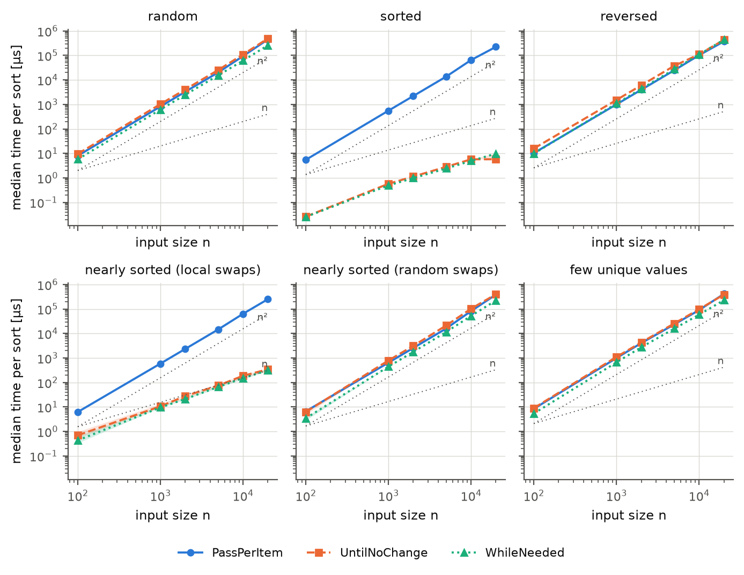
Figure 2. Median running time of one sort (µs, log–log axes) against input size, one panel per input order. Markers are the measured sizes; the shaded band is the 95 % CI over forks (mostly narrower than the markers); dotted grey lines show n and n² growth for reference. Log scales are used because sizes and times span several orders of magnitude.
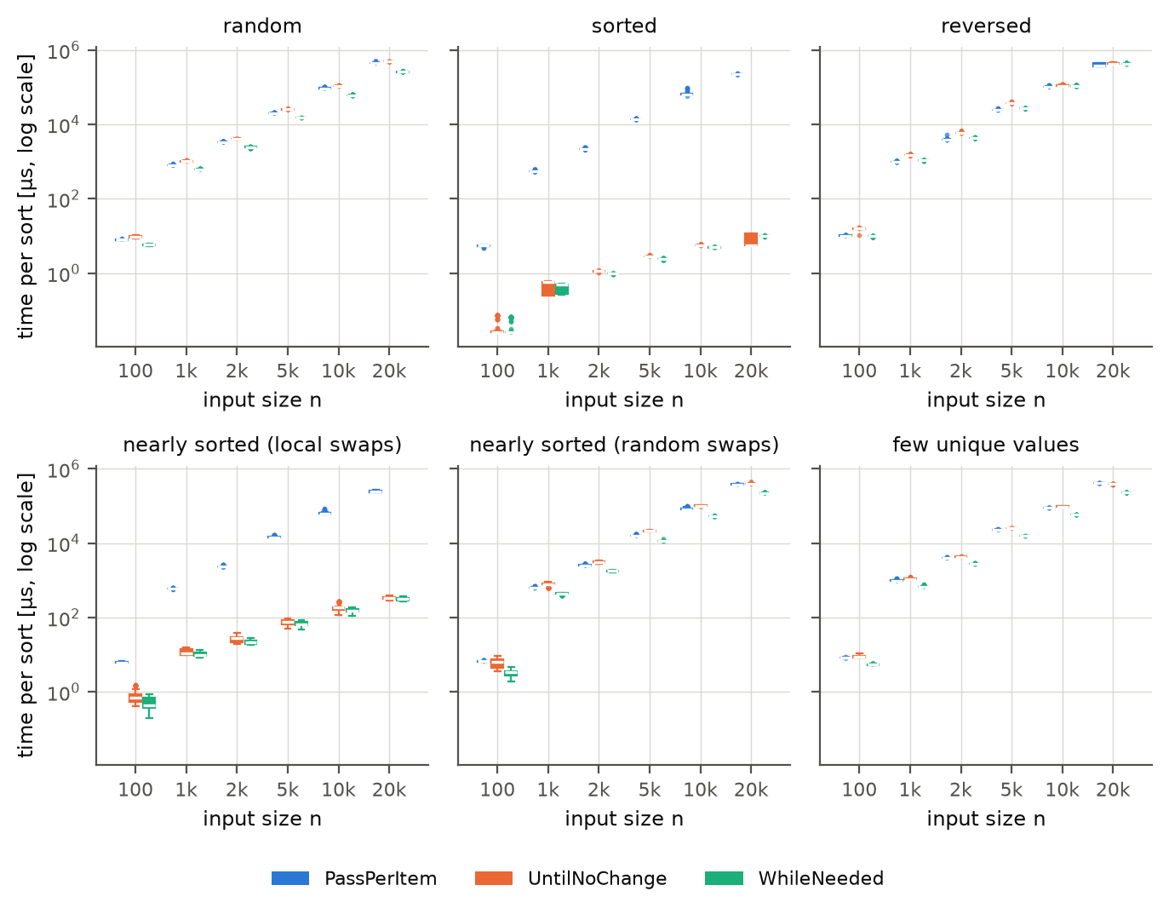
Figure 3. Distribution of the measured time per sort (all 300 batch measurements per box; logarithmic axis) for every input size, by input order and algorithm. Box = interquartile range, line = median, whiskers = 1.5 × IQR, points = outliers. Most boxes are very narrow because repeated measurements agree closely; the wide boxes (sorted, n = 1 000 and 20 000) are level shifts inside a JVM (Section 3.7).
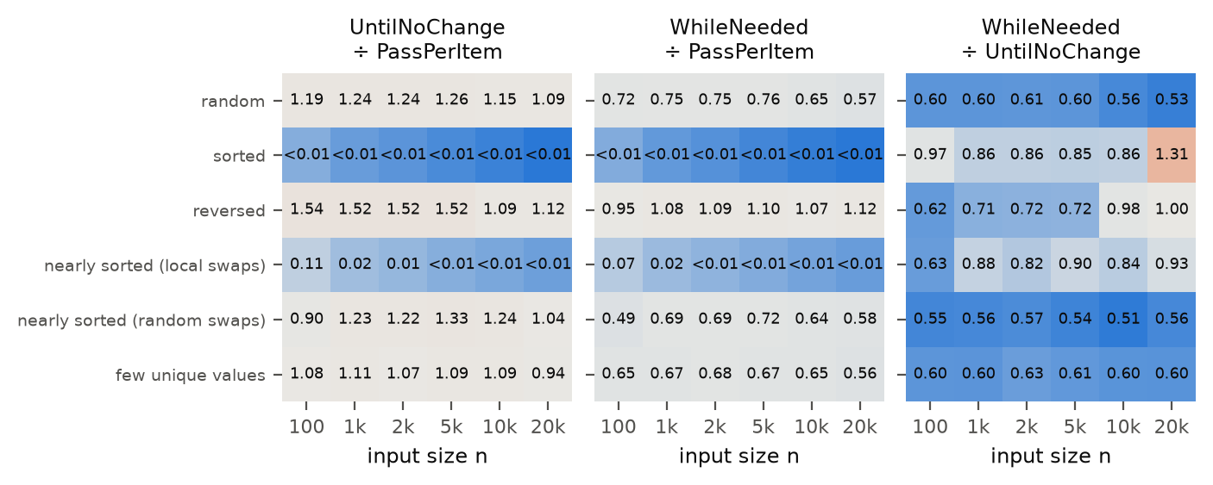
Figure 4. Time of one algorithm relative to another (geometric mean over forks of the paired per-fork ratios). Values below 1 mean the first-named algorithm is faster. Cells with n < 1 000 are descriptive only.
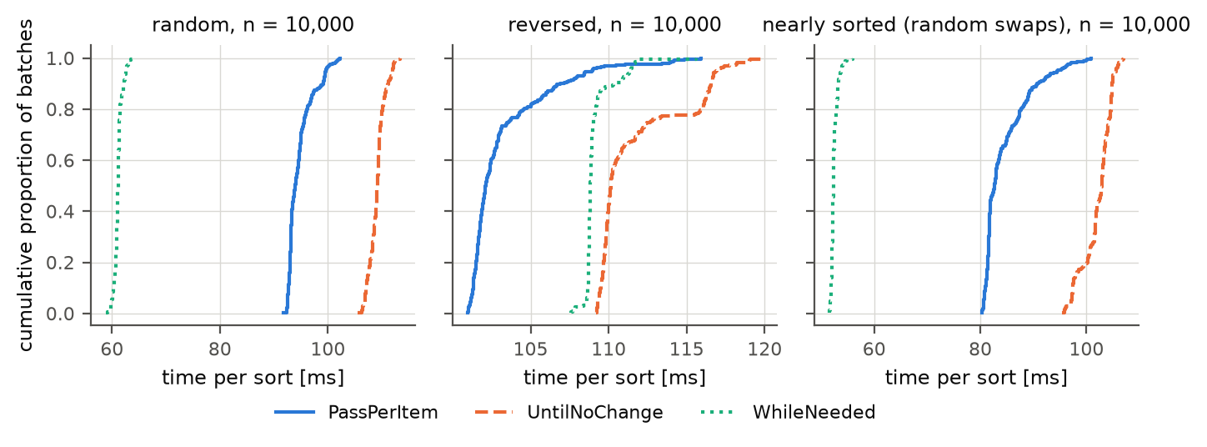
Figure 5. Empirical cumulative distribution functions of the time per sort for n = 10 000 on random, reversed and nearly sorted (random swaps) input. A curve further to the left is faster; a steep curve means repeatable timings.
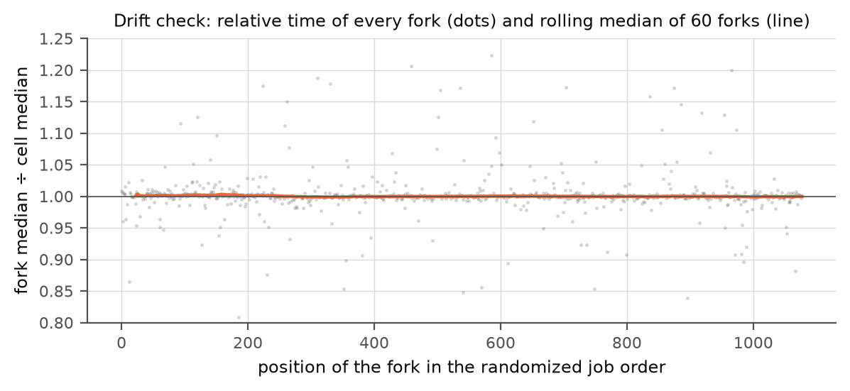
Figure 6. Check for slow drift of the machine during the 77-minute session: relative time of each job (to its cell median) in execution order, with rolling median.
Drift check: Spearman correlation between job position and relative time: ρ=-0.108, p=0.00123. The rolling median of the relative time stays within 0.999 to 1.003 of the cell median (Figure 6), so the drift is statistically detectable but tiny (later jobs were about 0.1–0.3 % faster): far smaller than the differences between algorithms. The 39 jobs that overlapped with logged activity of the assistant (smoke tests, git commits; results/full/interference_log.txt) have a median relative time of 1.002, the other jobs 1.000, so these short checks did not leave a visible trace.

3.2 Descriptive Statistics
For each of the 108 conditions we summarise the 300 measurements with the five-number summary: the minimum is the fastest batch observed; the first quartile (Q1) is the value below which the fastest quarter of the batches lies; the median is the middle value – half of the batches were faster, half slower; the third quartile (Q3) is the value below which three quarters of the batches lie; the maximum is the slowest batch. The distance Q3 − Q1 (the interquartile range) shows how much the measurements vary: a narrow range means the timing is repeatable. Table 2 gives the summary for n = 10 000; the tables for all sizes are in Appendix C. Times are per call of sort(), in the unit shown.
Table 2. Five-number summary of the time per sort, n = 10 000 (300 measurements per row). For sorted input the rows of the two early-stopping algorithms are about twice the steady-state values (Section 3.7).
Input order | Algorithm | Min | Q1 | Median | Q3 | Max
random | PassPerItem | 91.7 ms | 93.1 ms | 94.0 ms | 95.6 ms | 102 ms
random | UntilNoChange | 106 ms | 108 ms | 109 ms | 110 ms | 113 ms
random | WhileNeeded | 58.9 ms | 60.8 ms | 61.1 ms | 61.4 ms | 63.9 ms
sorted | PassPerItem | 58.2 ms | 63.4 ms | 64.6 ms | 65.6 ms | 94.8 ms
sorted | UntilNoChange | 5.46 µs | 5.71 µs | 5.72 µs | 5.75 µs | 6.08 µs
sorted | WhileNeeded | 4.87 µs | 4.90 µs | 4.92 µs | 4.96 µs | 5.31 µs
reversed | PassPerItem | 101 ms | 102 ms | 102 ms | 104 ms | 116 ms
reversed | UntilNoChange | 109 ms | 110 ms | 110 ms | 113 ms | 120 ms
reversed | WhileNeeded | 108 ms | 109 ms | 109 ms | 109 ms | 116 ms
nearly sorted (local swaps) | PassPerItem | 60.4 ms | 62.7 ms | 64.1 ms | 65.9 ms | 87.6 ms
nearly sorted (local swaps) | UntilNoChange | 120 µs | 157 µs | 186 µs | 191 µs | 273 µs
nearly sorted (local swaps) | WhileNeeded | 111 µs | 142 µs | 153 µs | 169 µs | 185 µs
nearly sorted (random swaps) | PassPerItem | 80.3 ms | 81.5 ms | 82.7 ms | 86.7 ms | 101 ms
nearly sorted (random swaps) | UntilNoChange | 95.3 ms | 101 ms | 103 ms | 104 ms | 107 ms
nearly sorted (random swaps) | WhileNeeded | 51.5 ms | 52.1 ms | 52.3 ms | 52.7 ms | 55.9 ms
few unique values | PassPerItem | 88.8 ms | 89.6 ms | 89.8 ms | 90.1 ms | 94.7 ms
few unique values | UntilNoChange | 96.8 ms | 97.4 ms | 97.6 ms | 98.1 ms | 99.0 ms
few unique values | WhileNeeded | 58.2 ms | 58.4 ms | 58.5 ms | 58.6 ms | 59.3 ms

The median over forks, the 95 % confidence intervals and the between-fork variation per condition are in the file analysis/out/main/summary_cells.csv.

3.3 Comparing the algorithms
Table 3 gives the paired ratio of the running times for the most informative sizes. Values below 1 mean that the first-named algorithm needs less time.
Table 3. Time ratios (geometric mean over the 10 paired forks) with 95 % confidence interval in brackets; ratios below 0.01 are written as 1/N, e.g. 1/970 means 970 times faster. For sorted input, the ratio WhileNeeded ÷ UntilNoChange is affected by level shifts and is about 0.98 in the steady state (Section 3.7).
Input order | n | UntilNoChange ÷ PassPerItem | WhileNeeded ÷ PassPerItem | WhileNeeded ÷ UntilNoChange
random | 1 000 | 1.24 [1.23, 1.26] | 0.75 [0.74, 0.76] | 0.60 [0.60, 0.61]
random | 5 000 | 1.26 [1.24, 1.28] | 0.76 [0.76, 0.76] | 0.60 [0.60, 0.61]
random | 20 000 | 1.09 [1.08, 1.10] | 0.57 [0.57, 0.58] | 0.53 [0.52, 0.53]
sorted | 1 000 | 1/970 [1/965, 1/975] | 1/1 123 [1/1 122, 1/1 125] | 0.86 [0.86, 0.87]
sorted | 5 000 | 1/4 824 [1/4 800, 1/4 848] | 1/5 649 [1/5 625, 1/5 673] | 0.85 [0.85, 0.86]
sorted | 20 000 | 1/29 807 [1/23 072, 1/38 509] | 1/22 830 [1/22 750, 1/22 911] | 1.31 [1.01, 1.68]
reversed | 1 000 | 1.52 [1.51, 1.53] | 1.08 [1.08, 1.08] | 0.71 [0.71, 0.71]
reversed | 5 000 | 1.52 [1.52, 1.53] | 1.10 [1.10, 1.10] | 0.72 [0.72, 0.72]
reversed | 20 000 | 1.12 [1.06, 1.18] | 1.12 [1.05, 1.18] | 1.00 [0.98, 1.02]
nearly sorted (local swaps) | 1 000 | 0.020 [0.017, 0.022] | 0.017 [0.016, 0.019] | 0.88 [0.82, 0.93]
nearly sorted (local swaps) | 5 000 | 1/196 [1/172, 1/222] | 1/218 [1/193, 1/246] | 0.90 [0.84, 0.96]
nearly sorted (local swaps) | 20 000 | 1/738 [1/691, 1/787] | 1/791 [1/743, 1/842] | 0.93 [0.91, 0.95]
nearly sorted (random swaps) | 1 000 | 1.23 [1.16, 1.30] | 0.69 [0.67, 0.70] | 0.56 [0.54, 0.58]
nearly sorted (random swaps) | 5 000 | 1.33 [1.31, 1.35] | 0.72 [0.72, 0.72] | 0.54 [0.53, 0.55]
nearly sorted (random swaps) | 20 000 | 1.04 [1.03, 1.05] | 0.58 [0.57, 0.58] | 0.56 [0.55, 0.56]
few unique values | 1 000 | 1.11 [1.10, 1.12] | 0.67 [0.66, 0.67] | 0.60 [0.60, 0.60]
few unique values | 5 000 | 1.09 [1.08, 1.10] | 0.67 [0.67, 0.67] | 0.61 [0.61, 0.62]
few unique values | 20 000 | 0.94 [0.93, 0.94] | 0.56 [0.56, 0.56] | 0.60 [0.59, 0.60]

3.4 Operation counts
To relate time to the work performed, an instrumented copy of the algorithms counted the comparisons (calls to compareTo) and the inversions (= swaps, identical for all three algorithms) for every cell (results/operation_counts.csv; Figure 7 shows n = 10 000).
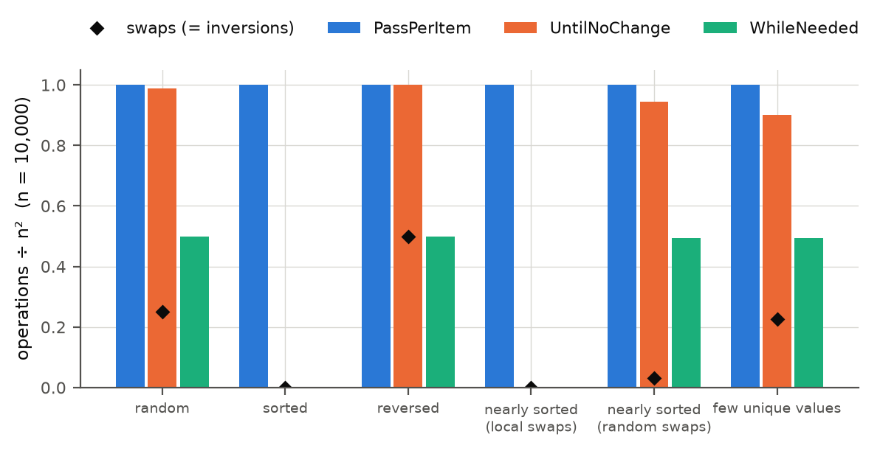
Figure 7. Number of comparisons (bars, as a fraction of n²) and of swaps (diamonds) per algorithm and input order for n = 10 000.

3.5 Decision metric: worst-case slowdown
For the recommendation, we compare every algorithm with the fastest one in each condition. The slowdown of an algorithm in a cell is its median time divided by the smallest median time of the three algorithms in that cell (1.00 = fastest). Table 4 summarises the 30 cells with n ≥ 1 000.
Table 4. Slowdown relative to the fastest algorithm per cell (n ≥ 1 000), from the medians of all 30 batches. Section 3.7 repeats this analysis for the steady state.
Algorithm | Fastest in | Within 5 % of best | Geometric-mean slowdown | Worst slowdown | Where
PassPerItem | 5 / 30 | 5 / 30 | 12.80 | 38 900 | sorted, n = 20 000
UntilNoChange | 1 / 30 | 1 / 30 | 1.45 | 1.96 | nearly sorted (random swaps), n = 10 000
WhileNeeded | 24 / 30 | 24 / 30 | 1.03 | 1.70 | sorted, n = 20 000

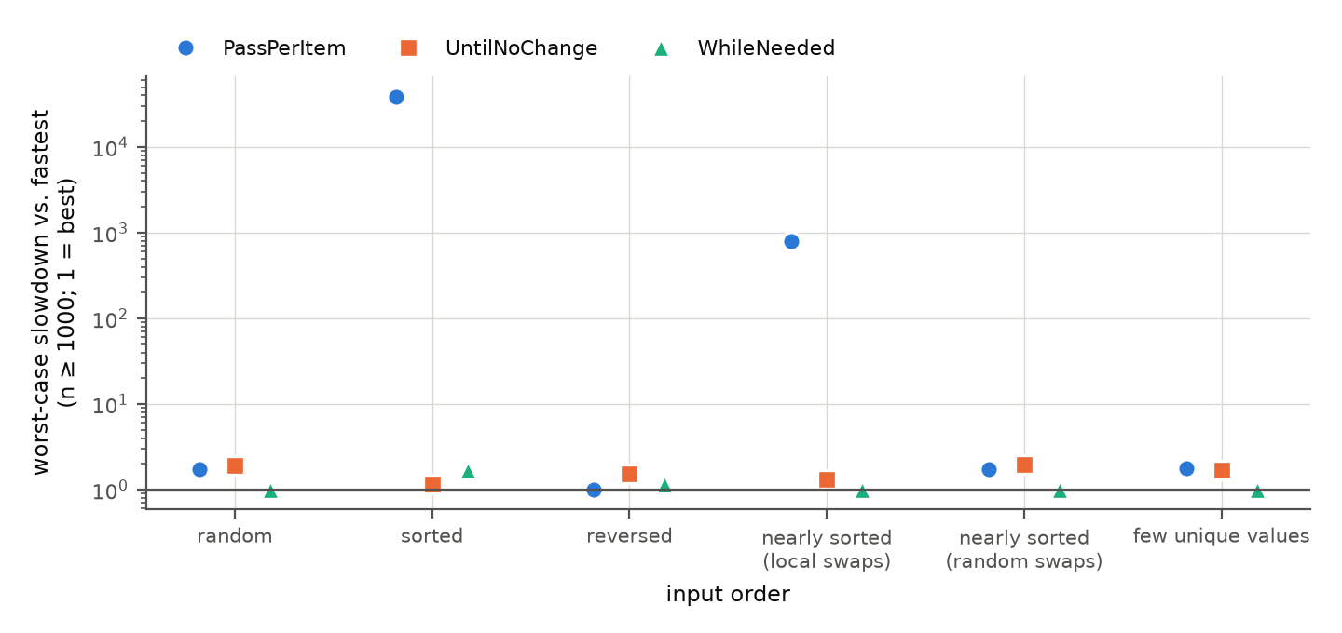
Figure 8. Worst slowdown relative to the best algorithm per input order (n ≥ 1 000; logarithmic axis, 1 = best).

3.6 Hypothesis checks
Table 5. Verdicts of the pre-registered hypotheses based on the main data (before re-measurement; Section 3.7 and Appendix F give the sensitivity analyses).
Hypothesis | Verdict under the registered rule | Cells supported | Cells falsified | Cells inconclusive
H1 | Supported | 10 | 0 | 0
H2 | Falsified (1 of 9 cells); 1 inconclusive | 7 | 1 | 1
H3 | Falsified (5 of 6 cells) | 1 | 5 | 0
H4 | Supported | 6 | 0 | 0
H5 | Falsified (1 of 6 cells) | 5 | 1 | 0
H6 | Falsified (5 of 60 cells); 1 inconclusive | 54 | 5 | 1

3.7 Level shifts inside a JVM and a steady-state check
After the main analysis, an independent review of the raw data (by a second AI assistant session without prior context, commissioned by the first author) found that in some cells the time per sort changes inside a fork. For every fork we compared the median of the first 10 with the median of the last 10 of the 30 timed batches. In 46 of the 1 080 forks the two differ by more than 20 %, and in 39 more by 5–20 %. All large shifts go in the same direction (the later batches are faster) and the flagged cells all have very short sorts (Table 6). In sorted input with n = 1 000, all 20 forks of both early-stopping algorithms speed up by a factor of about 2 (UntilNoChange from about 570 ns to about 250 ns, WhileNeeded from about 490 ns to about 270 ns); in sorted input with n = 20 000, all ten forks of UntilNoChange go from about 11.4 µs to about 5.7 µs. Figure 9 shows the trajectories. The five-number summaries of Appendix C (and Table 2 for n = 10 000) mix the two levels for these cells. The cause is most likely that the JIT compiler finishes compiling the loop that runs the batches while it is being timed; the main harness ran only two untimed batches before the timed ones, and it did not record compilation events, so this explanation is untested.
Table 6. Cells of the main data with level shifts inside the forks (no other cell has a fork with a shift above 20 %). Last ÷ first and switch batch are medians over the forks with a shift.
Input order | n | Algorithm | Forks with a shift > 20 % | Time of last 10 ÷ first 10 batches | Batch at which the shift happens
nearly sorted (local swaps) | 100 | UntilNoChange | 8 of 10 | 0.79 | 14
nearly sorted (local swaps) | 100 | WhileNeeded | 3 of 10 | 0.74 | 11
nearly sorted (local swaps) | 1 000 | UntilNoChange | 1 of 10 | 0.83 | 16
nearly sorted (random swaps) | 100 | WhileNeeded | 1 of 10 | 0.76 | 25
sorted | 100 | UntilNoChange | 2 of 10 | 0.45 | 2
sorted | 100 | WhileNeeded | 1 of 10 | 0.51 | 2
sorted | 1 000 | UntilNoChange | 10 of 10 | 0.44 | 22
sorted | 1 000 | WhileNeeded | 10 of 10 | 0.54 | 23
sorted | 20 000 | UntilNoChange | 10 of 10 | 0.49 | 13

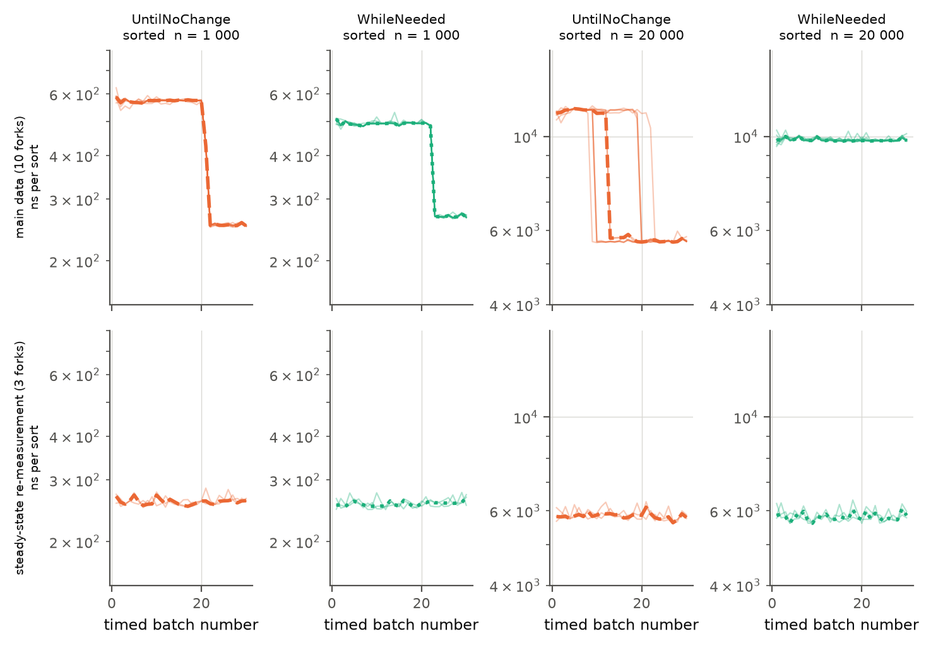
Figure 9. Time per sort of every timed batch for sorted input, n = 1 000 and 20 000. Top: main data (10 forks, thin lines; thick line = median over forks). Bottom: steady-state re-measurement (3 forks) with a long stabilisation of the batch loop before the timed batches. Logarithmic y axis.
We therefore report three analyses of the same design: (1) all batches, the planned analysis of Sections 3.2–3.6; (2) late batches, the same analysis using only batches 21–30 of every fork; (3) a steady-state re-measurement of all 108 cells with exp01.SteadyWorker, which after the single-sort warm-up runs whole batches through the method that is later timed until the batch time is stable (window of 50 batches, tolerance 3 %, at least 400 rounds and 8 s of wall-clock time for short sorts, at most 15 s of batch time) and then takes the 30 timed batches. It uses the same JDK, flags and data (forks 0–2 of the main data, same seed); 3 forks per cell because of the time available (about one hour). Worker, which produced the main data, behaves as before (a later commit only added a locale-independent number format).
In the steady-state run the stabilisation criterion was met in all 324 forks; 1 fork has a level shift above 20 % (3 more between 5 and 20 %) and 1 timed batch contained a garbage collection (flagged). The run lasted 56 minutes (20:13–21:09 on 9 November 2026); it started on battery power (87 %) and the charger was connected a few minutes later, unlike in the main run; no other program ran except one low-priority test of the analysis script (results/full/interference_log.txt). In the steady state WhileNeeded on sorted input with n = 20 000 also reaches about 5.8 µs; its switch comes much later than UntilNoChange's.
The comparison of first and last batches cannot see a slow level that lasts for all 30 batches (they cover only about 60 ms). Comparing forks 0–2 of the main data directly with the steady-state run (same data) shows that the main data are further from the steady state than Table 7 suggests: 19 of 90 cells with n ≥ 1 000 and 16 of 18 cells with n = 100 differ by more than 10 %. In sorted input with n = 2 000, 5 000 and 10 000 the early-stopping algorithms need 0.45–0.59 of their main-data time in the steady state (their trajectories in the main data are flat, the switch had not yet happened), in nearly sorted input with local swaps (n ≥ 1 000) 0.77–0.95, and PassPerItem at n = 100 0.53–0.64. The absolute times of the main data (Table 2, Appendix C, Table 3's ratios on sorted input) are therefore too high for these cells, by up to a factor of 2; the overall verdicts are not changed (Table 7), but the magnitudes in Section 4.1 and some worst-case numbers are (the cell-by-cell comparison is in analysis/out/steady_check/steady_vs_main_cells.csv).
Table 7. The three analyses compared (n ≥ 1 000; 'fastest' counts the cells in which the algorithm has the smallest median time).
Analysis | Cells falsified (H1 and H4: supported in all) | WhileNeeded fastest | WhileNeeded worst slowdown | UntilNoChange fastest | UntilNoChange worst slowdown | PassPerItem worst slowdown
main (all 30 batches) | H2: 1/9 (+1 inconclusive) · H3: 5/6 · H5: 1/6 · H6: 5/60 (+1 inconclusive) | 24 / 30 | 1.70 | 1 / 30 | 1.96 | 38 900
main, last 10 batches | H2: 1/9 (+1 inconclusive) · H3: 5/6 · H5: 0/6 (+1 inconclusive) · H6: 6/60 (+1 inconclusive) | 23 / 30 | 1.73 | 2 / 30 | 1.96 | 39 600
steady-state re-measurement | H2: 1/9 (+1 inconclusive) · H3: 5/6 · H5: 1/6 · H6: 4/60 (+1 inconclusive) | 25 / 30 | 1.16 | 0 / 30 | 2.59 | 39 700

Table 8. Median time per sort in the cells most affected by level shifts, in the three analyses.
Analysis | Input order | n | PassPerItem | UntilNoChange | WhileNeeded | WhileNeeded ÷ UntilNoChange
main (all 30 batches) | sorted | 100 | 5.46 µs | 26.2 ns | 25.5 ns | 0.97
main (all 30 batches) | sorted | 1 000 | 553 µs | 571 ns | 492 ns | 0.86
main (all 30 batches) | sorted | 20 000 | 223 ms | 5.75 µs | 9.79 µs | 1.70
main (all 30 batches) | nearly sorted (local swaps) | 100 | 6.23 µs | 697 ns | 432 ns | 0.62
main, last 10 batches | sorted | 100 | 5.55 µs | 25.8 ns | 25.2 ns | 0.97
main, last 10 batches | sorted | 1 000 | 553 µs | 253 ns | 268 ns | 1.06
main, last 10 batches | sorted | 20 000 | 223 ms | 5.64 µs | 9.78 µs | 1.73
main, last 10 batches | nearly sorted (local swaps) | 100 | 6.23 µs | 680 ns | 431 ns | 0.63
steady-state re-measurement | sorted | 100 | 2.92 µs | 26.4 ns | 26.2 ns | 0.99
steady-state re-measurement | sorted | 1 000 | 569 µs | 261 ns | 257 ns | 0.99
steady-state re-measurement | sorted | 20 000 | 229 ms | 5.86 µs | 5.77 µs | 0.98
steady-state re-measurement | nearly sorted (local swaps) | 100 | 3.88 µs | 798 ns | 505 ns | 0.63

3.8 Further experiments and re-measurement (summary)
Besides the main experiment we ran the follow-up experiments of Appendix E and the pre-registered re-measurement of Appendix F. They are descriptive checks of the consistency of the ranking and are not used for the hypothesis verdicts. Table 9 gives the main numbers; the details, figures and the discussion of the differences are in the appendices.
Table 9. Summary of the further experiments.
Experiment | Main number | Details
Garbage collectors, JDK versions, polluted JIT profile, other computers (n ∈ {1 000, 5 000, 10 000}) | WhileNeeded is the fastest algorithm in 15–18 of 18 cells in every setting with 18 cells (8 of 10 in the polluted setting); its worst slowdown against the best is 1.00–1.10× | Appendix E.2, E.9, D
String instead of Integer elements | WhileNeeded ÷ PassPerItem on reversed input, n = 5 000: 0.58 (main data with Integer: 1.10) | Appendix E.1
Tiny arrays (n = 2 … 50) | WhileNeeded fastest in 77 % of 48 cells (and in all 8 input orders at n = 50); differences up to about 1–2 µs on non-sorted input | Appendix E.3
Other input shapes | WhileNeeded fastest in 13 of 15 cells, never more than 0.8 % slower than the best | Appendix E.4
Cold start, JMH | first call of PassPerItem (random, n = 100) 8.6× the time of calls 20 and later; JMH ratios agree with ours within 1.2 % (random, reversed) | Appendix E.5, E.6
Scaling, replication, load, correctness | exponents 2.0–2.1 (random) and 1.0 (sorted, early-stopping); 94 % of cells within 5 % in the replication; 20 139 correctness checks passed | Appendix E.7
JIT compiler level | UntilNoChange ÷ PassPerItem on random input, n = 2 000: 1.22 (default), 1.05 (C1 only), 0.98 (interpreter) | Appendix E.8
Re-measurement of 10 uncertain groups (20 more forks) | one hypothesis cell changes (H2, random, n = 10 000: inconclusive → falsified) | Appendix F

4. Discussion

4.1 Compare Hypothesis to Results
Under the rule registered in HYPOTHESES.md (one clear violation falsifies), H1 and H4 were supported and H2, H3, H5 and H6 were falsified in the main data (1 of 9 cells falsified, 1 inconclusive for H2, 5 of 6 cells falsified for H3, 1 of 6 cells falsified for H5, 5 of 60 cells falsified, 1 inconclusive for H6). The steady-state re-measurement of Section 3.7 gives the same verdicts (cells falsified: H2 1, H3 5, H5 1, H6 4); only H5 is fragile (below). The qualitative predictions were right (early stopping helps enormously on sorted and nearly sorted input, WhileNeeded needs the fewest comparisons, growth is quadratic or linear as expected). Wrong were our thresholds and the assumption that fewer comparisons always mean less time. The hypotheses were not changed afterwards.
H1 – sorted input: supported. PassPerItem is between 970× and 29 807× slower than the early-stopping algorithms (lowest CI bound 965×; steady state: 2 195×–39 502×, see Section 3.7), far beyond the predicted 100×: PassPerItem makes n(n−1) comparisons whatever the input, the others a single pass of n−1 comparisons.
H2 – random input: falsified in one cell, inconclusive in one. WhileNeeded is the fastest algorithm in every random cell with n ≥ 5 000 (it needs 0.57–0.76 of PassPerItem's time). UntilNoChange and PassPerItem are not within 15 % of each other at n = 5 000 (1.26×, CI 1.24–1.28), inconclusive at 10 000 (1.15×; falsified after re-measurement, Appendix F) and within 15 % at 20 000 (1.09×). Both make about n² comparisons on random data, so the gap must come from the cost per loop iteration; our conjecture is that the flag UntilNoChange sets inside the swap branch slows the compiled loop. This is supported only indirectly: with only the C1 compiler or the interpreter the gap disappears (Appendix E.8), so the C2 compiler is necessary for it. We did not inspect the generated machine code.
H3 – reversed input: falsified in 5 of 6 cells. WhileNeeded is clearly faster than UntilNoChange at n = 5 000 (0.72×) but 10 % slower than PassPerItem (CI 1.095–1.100), and at n ≥ 10 000 no faster than UntilNoChange (1.00× at 20 000). This disadvantage (7–12 % in the main data, up to 16 % at n = 20 000 in the steady state) is not a robust property of the algorithms: it occurs only in the main setting (Homebrew OpenJDK 26.0.1 on the first M3 Pro, Serial or Parallel collector) and is absent in every other setting we tried (G1, other JDKs, two other computers, String elements, a polluted JIT profile, C2 switched off; Appendix E). Its cause is unknown; vendor build, patch level and power state are confounded with the Java version (Appendix E.9).
H4 – locally disturbed input: supported. Both early-stopping algorithms are between 196× and 791× faster than PassPerItem (lowest CI bound 172×; steady state: 253×–987×).
H5 – growth with n: falsified in 1 of 6 cells. Only PassPerItem on random input grows by more than allowed when n doubles from 10 000 to 20 000: 4.78× (CI 4.71–4.86) against 4.7. The local scaling exponents (Appendix E.7) are about 1.99 for n ≤ 5 000 and 2.05 for n ≥ 20 000 but 2.10–2.40 between 5 000 and 15 000, a localised steepening that a cache effect might explain (not tested). The verdict is fragile: the interval only just excludes 4.7, and in the late-batch analysis of Section 3.7 the cell is inconclusive.
H6 – recommendation criterion: falsified in 5 of 60 comparisons (one more inconclusive). WhileNeeded is more than 5 % slower than another algorithm only on reversed input, against PassPerItem (7–12 % in the main data, up to 16 % in the steady state; see H3), plus one cell that is inconclusive in the all-batches analysis (sorted, n = 20 000, against UntilNoChange) and supported in the steady state. The registered rule "if this holds, WhileNeeded is recommended" therefore does not fire; the recommendation in Section 4.3 rests on a post-hoc criterion, the worst-case slowdown of Section 3.5.
Level shifts inside a JVM. A review of the raw data by a second AI assistant session found that for very short sorts the speed changed inside the 30 timed batches of a fork, most likely because the JIT compiler finished compiling the loop that runs the batches while it was being timed (Section 3.7; compilation events were not recorded). Our first explanation, a "bimodal" JIT state that depends on the JVM, was wrong: almost all forks go through the same switch, only at different batches, and WhileNeeded's switch on sorted input with n = 20 000 comes much later than UntilNoChange's (main data: 9.79 µs against 5.75 µs; steady state: 5.77 µs against 5.86 µs). The steady-state analysis changes two cell verdicts (both in H6) and no overall verdict, but it changes magnitudes: main-data times of the early-stopping algorithms on sorted and nearly sorted input (and of all n = 100 cells) are up to a factor 2 too high, WhileNeeded's worst slowdown is 1.16 instead of 1.70, and UntilNoChange's 2.59 instead of 1.96. The recommendation is the same in all analyses.

4.2 Limitations and Threats to Validity
- Measurement validity: JIT state during the timed batches. The harness warmed up with single sorts and only two untimed batches of the loop that runs the timed batches. In 46 of 1 080 forks (very short sorts) the speed changed by more than 20 % inside the fork, and 19 of 90 cells with n ≥ 1 000 and 16 of 18 cells with n = 100 are more than 10 % off the steady state even where no shift is visible (Section 3.7). We report all-batches, late-batch and steady-state analyses, but the steady-state run has only 3 forks, could itself miss shifts later than its stabilisation (at least 8 s), and no analysis monitored JIT compilations. A harness that records compilation events (a compilation MXBean or -XX:+PrintCompilation) would close this gap.
- Machines and JVMs. The complete data come from one Apple M3 Pro laptop (ARM, performance and efficiency cores, no core pinning; clock frequency and temperature not recorded). A reduced design was repeated on a second M3 Pro and on one x86 PC (Appendix E.9); the ranking holds there, the reversed-input anomaly does not appear, and since it also disappears under JDK 25.0.5 on the main laptop, JIT effects depend on the JDK build; a dependence on the hardware cannot be excluded. The second-machine runs are noisier (about 6–10 % within a fork, 28 % for the JDK 17 desktop run) than the main run (4.9 %). We varied JDK versions (8, 17, 21, 25, 26) and collectors (Serial, Parallel, G1) but only HotSpot-based JVMs from several vendors, not OpenJ9 or GraalVM. Future work: the full design on more machines (including an x86 server), the two missing runs (JDK 26.0.1 on x86, JDK 26.0.2.1 on the M3 Pro), and an inspection of the C2 machine code.
- Inputs, element types, real use. The six input orders and five extra shapes are classical but synthetic, and the arrays hold boxed Integers allocated in array order, which has better memory locality than in a long-running application. Only Integer (and, as a check, String and a polluted-JIT variant) was measured; expensive comparators should favour fewer comparisons, i.e. WhileNeeded, but we did not measure them. The design measures optimised code in a clean JVM; a real application is about 3× slower with a polluted JIT profile and much slower in the first calls (Appendices E.2, E.5), so the absolute numbers should not be quoted as customer-facing performance, only the ranking. Samples of Bubble Inc.'s real data and comparators, and measurements inside a representative application, would close these gaps.
- Statistical limits. Ten JVM forks per cell give confidence intervals of about ±1 % where the JIT is stable and wide ones where it is not (sorted n = 20 000; nearly-local inputs, whose data differ between forks); the t intervals are then approximate. Batches within a JVM are not independent, which is why the unit of inference is the fork median. Several hundred intervals were computed without correction for multiple comparisons; the conclusions rest on effects that are large compared with the intervals. The follow-ups use 3–5 forks per cell and no pre-registered thresholds. The run order was randomised but not counterbalanced (e.g. a Latin square). The ranking of the algorithms depends on the input order (an interaction), which is why every order is analysed separately. More forks, bootstrap intervals and a Holm correction would make the intervals more reliable.
- Pre-registration and post-hoc analysis. The hypotheses (01:16) and the analysis code (01:34) were committed before the main data were analysed, and the re-measurement rule (01:36) while the main run was in progress; the timestamps are local git times and the first push to GitHub came after the main run. A pilot (01:17–01:20) had already hinted at some of the later falsifications. The worst-case slowdown metric behind the recommendation (Section 3.5), the late-batch and steady-state analyses, the follow-ups and the runs on other computers came after seeing the main results and are exploratory; a new pre-registered experiment with the slowdown criterion fixed in advance would make them confirmatory.
- Time and interference. The experiment ran overnight with the laptop connected to AC power (recorded at the start) and heavy applications closed. Four short git commits and a few low-priority tests ran at the same time; they are logged (results/full/interference_log.txt), and the 39 overlapping jobs are indistinguishable from the others (Section 3.1). The follow-ups ran afterwards, one after the other, with a few logged analysis scripts at the lowest priority.
- Scope. Only running time was considered (as requested). Memory use is identical (in place) and all three are stable sorts; code size and readability were out of scope.

4.3 Conclusions
Recommendation: ship BubbleSortWhileNeeded. In the 30 conditions with n ≥ 1 000 it is the fastest algorithm in 24 in the main data and in 25 in the steady-state re-measurement; its geometric-mean slowdown against the best algorithm is 1.03 (1.02) and its worst slowdown is 1.16× (steady state; reversed input, n = 20 000, an absolute loss of 62 ms per sort). UntilNoChange is the fastest in 1 cell (0 in the steady state) and up to 2.0× (2.6× in the steady state, in a single 3-fork cell) slower than the best (up to 242 ms per sort); PassPerItem is up to about 38 900× slower on sorted data (at least 50× on sorted or locally disturbed input with n ≥ 1 000; up to 244 ms per sort). The criterion is post hoc (smallest worst-case slowdown) because the pre-registered criterion H6 is not met.
Where WhileNeeded is not the best. (1) On reversed input and cheap Integer comparisons it is 7–16 % slower than PassPerItem in the main setting only (see H3). (2) For arrays of 20 elements or fewer, UntilNoChange or PassPerItem win some cases (WhileNeeded wins all 8 input orders at n = 50), by at most about 1–2 µs (Appendix E.3). (3) On sorted input the two early-stopping algorithms are equally fast in the steady state; the differing all-batches medians of the main data are an artefact of level shifts (Section 3.7).
Beyond the decision. Running time is not predictable from comparison counts alone: H2, H3 and H6 failed because their thresholds were derived from counting comparisons. A benchmark must warm up the code path it measures, and fresh-JVM repetitions with a check for level shifts inside each run are the minimum for credible Java benchmarks; our main harness missed this for very short sorts until a review found it. Open: the mechanism of the C2 effects (not examined at machine-code level) and whether the reversed-input anomaly is a property of JDK 26.0.1 or of the Homebrew build.

Appendix

A. Materials
The three algorithms under test are the classes provided with the assignment, used unmodified (src/exp01/BubbleSortPassPerItem.java, BubbleSortUntilNoChange.java, BubbleSortWhileNeeded.java, interface Sorter.java). No informed-consent documents were needed because there were no human participants.

B. Reproduction Package
Everything needed to recreate every number, table and figure of this report is in the public repository https://github.com/vaizan4ikys/bubble-sort-benchmark (data, analysis and report scripts as of commit b352969): the raw measurements (results/full/raw.csv: one line per timed batch, 32 400 lines), the environment records, the operation counts, the code of the harness, the orchestration and analysis scripts, the pre-registered hypotheses (HYPOTHESES.md) and the pre-registered re-measurement rule (REMEASURE_RULE.md). To reproduce: build with javac, run scripts/run_experiment.py and the follow-up scripts, then the analysis scripts in the order given in README.md.
- results/full/ – main experiment (raw.csv, run.log, environment.txt, interference_log.txt)
- results/remeasure/ – the 20 additional forks of the 10 uncertain groups (Appendix F)
- results/steady/ – the steady-state re-measurement of the full design (Section 3.7)
- results/ext_*/ – follow-up experiments, each with its own raw.csv and environment.txt
- results/portable_*/ – the reduced design on two other computers (run by the second author)
- results/pilot/ – pilot run made before the main experiment with a not yet committed version of the harness, used only to choose the parameters; results/pilot_ext/ – short smoke test of ExtendedWorker made during the main run (see results/full/interference_log.txt)
- analysis/out/ – all derived tables and figures of this report

C. Five-number summaries of all conditions
Minimum, first quartile, median, third quartile and maximum of the 300 measurements per condition (per call of sort()).

random
n | algorithm | min | Q1 | median | Q3 | max
100 | PassPerItem | 7.76 µs | 7.88 µs | 7.99 µs | 8.06 µs | 8.52 µs
100 | UntilNoChange | 8.64 µs | 9.19 µs | 9.63 µs | 9.83 µs | 10.4 µs
100 | WhileNeeded | 5.40 µs | 5.53 µs | 5.77 µs | 5.87 µs | 6.32 µs
1000 | PassPerItem | 798 µs | 812 µs | 816 µs | 819 µs | 866 µs
1000 | UntilNoChange | 980 µs | 1.00 ms | 1.02 ms | 1.03 ms | 1.11 ms
1000 | WhileNeeded | 592 µs | 609 µs | 615 µs | 620 µs | 665 µs
2000 | PassPerItem | 3.24 ms | 3.27 ms | 3.28 ms | 3.32 ms | 3.58 ms
2000 | UntilNoChange | 3.90 ms | 4.03 ms | 4.09 ms | 4.12 ms | 4.28 ms
2000 | WhileNeeded | 2.33 ms | 2.46 ms | 2.48 ms | 2.50 ms | 2.59 ms
5000 | PassPerItem | 20.0 ms | 20.1 ms | 20.1 ms | 20.3 ms | 21.3 ms
5000 | UntilNoChange | 24.6 ms | 25.1 ms | 25.3 ms | 25.5 ms | 26.7 ms
5000 | WhileNeeded | 15.2 ms | 15.3 ms | 15.3 ms | 15.4 ms | 15.6 ms
10000 | PassPerItem | 91.7 ms | 93.1 ms | 94.0 ms | 95.6 ms | 102 ms
10000 | UntilNoChange | 106 ms | 108 ms | 109 ms | 110 ms | 113 ms
10000 | WhileNeeded | 58.9 ms | 60.8 ms | 61.1 ms | 61.4 ms | 63.9 ms
20000 | PassPerItem | 444 ms | 449 ms | 451 ms | 454 ms | 523 ms
20000 | UntilNoChange | 483 ms | 490 ms | 492 ms | 493 ms | 504 ms
20000 | WhileNeeded | 255 ms | 257 ms | 258 ms | 260 ms | 284 ms

sorted
n | algorithm | min | Q1 | median | Q3 | max
100 | PassPerItem | 4.89 µs | 5.44 µs | 5.46 µs | 5.54 µs | 5.68 µs
100 | UntilNoChange | 25.5 ns | 25.8 ns | 26.2 ns | 26.8 ns | 74.6 ns
100 | WhileNeeded | 24.9 ns | 25.2 ns | 25.5 ns | 25.7 ns | 66.8 ns
1000 | PassPerItem | 543 µs | 552 µs | 553 µs | 555 µs | 642 µs
1000 | UntilNoChange | 250 ns | 256 ns | 570 ns | 575 ns | 624 ns
1000 | WhileNeeded | 264 ns | 273 ns | 493 ns | 495 ns | 531 ns
2000 | PassPerItem | 2.10 ms | 2.19 ms | 2.20 ms | 2.21 ms | 2.40 ms
2000 | UntilNoChange | 1.05 µs | 1.12 µs | 1.13 µs | 1.14 µs | 1.21 µs
2000 | WhileNeeded | 924 ns | 964 ns | 975 ns | 981 ns | 1.02 µs
5000 | PassPerItem | 13.6 ms | 13.6 ms | 13.6 ms | 13.7 ms | 14.8 ms
5000 | UntilNoChange | 2.80 µs | 2.82 µs | 2.82 µs | 2.85 µs | 3.09 µs
5000 | WhileNeeded | 2.30 µs | 2.41 µs | 2.42 µs | 2.43 µs | 2.58 µs
10000 | PassPerItem | 58.2 ms | 63.4 ms | 64.6 ms | 65.6 ms | 94.8 ms
10000 | UntilNoChange | 5.46 µs | 5.71 µs | 5.72 µs | 5.75 µs | 6.08 µs
10000 | WhileNeeded | 4.87 µs | 4.90 µs | 4.92 µs | 4.96 µs | 5.31 µs
20000 | PassPerItem | 223 ms | 223 ms | 223 ms | 224 ms | 237 ms
20000 | UntilNoChange | 5.60 µs | 5.64 µs | 5.74 µs | 11.5 µs | 11.8 µs
20000 | WhileNeeded | 9.47 µs | 9.76 µs | 9.79 µs | 9.86 µs | 10.3 µs

reversed
n | algorithm | min | Q1 | median | Q3 | max
100 | PassPerItem | 9.95 µs | 10.2 µs | 10.3 µs | 10.4 µs | 10.9 µs
100 | UntilNoChange | 10.5 µs | 15.6 µs | 15.8 µs | 15.9 µs | 16.7 µs
100 | WhileNeeded | 9.11 µs | 9.75 µs | 9.76 µs | 9.79 µs | 10.1 µs
1000 | PassPerItem | 986 µs | 997 µs | 998 µs | 1.00 ms | 1.11 ms
1000 | UntilNoChange | 1.44 ms | 1.51 ms | 1.51 ms | 1.53 ms | 1.63 ms
1000 | WhileNeeded | 1.03 ms | 1.08 ms | 1.08 ms | 1.08 ms | 1.14 ms
2000 | PassPerItem | 3.88 ms | 3.95 ms | 3.96 ms | 3.97 ms | 5.30 ms
2000 | UntilNoChange | 5.97 ms | 6.02 ms | 6.02 ms | 6.04 ms | 6.91 ms
2000 | WhileNeeded | 4.22 ms | 4.32 ms | 4.32 ms | 4.33 ms | 4.64 ms
5000 | PassPerItem | 24.4 ms | 24.6 ms | 24.6 ms | 24.8 ms | 27.9 ms
5000 | UntilNoChange | 37.0 ms | 37.5 ms | 37.5 ms | 37.6 ms | 41.6 ms
5000 | WhileNeeded | 26.6 ms | 27.0 ms | 27.0 ms | 27.0 ms | 27.4 ms
10000 | PassPerItem | 101 ms | 102 ms | 102 ms | 104 ms | 116 ms
10000 | UntilNoChange | 109 ms | 110 ms | 110 ms | 113 ms | 120 ms
10000 | WhileNeeded | 108 ms | 109 ms | 109 ms | 109 ms | 116 ms
20000 | PassPerItem | 372 ms | 372 ms | 373 ms | 437 ms | 450 ms
20000 | UntilNoChange | 430 ms | 431 ms | 432 ms | 452 ms | 475 ms
20000 | WhileNeeded | 431 ms | 435 ms | 435 ms | 436 ms | 446 ms

nearly sorted (local swaps)
n | algorithm | min | Q1 | median | Q3 | max
100 | PassPerItem | 6.19 µs | 6.21 µs | 6.27 µs | 6.47 µs | 6.69 µs
100 | UntilNoChange | 409 ns | 545 ns | 713 ns | 865 ns | 1.53 µs
100 | WhileNeeded | 198 ns | 373 ns | 444 ns | 690 ns | 867 ns
1000 | PassPerItem | 576 µs | 588 µs | 590 µs | 592 µs | 648 µs
1000 | UntilNoChange | 9.63 µs | 9.78 µs | 10.7 µs | 14.1 µs | 15.7 µs
1000 | WhileNeeded | 8.40 µs | 9.35 µs | 9.59 µs | 11.4 µs | 13.2 µs
2000 | PassPerItem | 2.28 ms | 2.33 ms | 2.34 ms | 2.36 ms | 2.67 ms
2000 | UntilNoChange | 19.3 µs | 21.3 µs | 27.9 µs | 29.9 µs | 37.8 µs
2000 | WhileNeeded | 18.9 µs | 19.7 µs | 21.1 µs | 23.6 µs | 28.5 µs
5000 | PassPerItem | 14.4 ms | 14.5 ms | 14.6 ms | 14.7 ms | 16.7 ms
5000 | UntilNoChange | 50.0 µs | 67.2 µs | 74.9 µs | 87.4 µs | 92.7 µs
5000 | WhileNeeded | 48.3 µs | 63.3 µs | 66.2 µs | 76.1 µs | 87.7 µs
10000 | PassPerItem | 60.4 ms | 62.7 ms | 64.1 ms | 65.9 ms | 87.6 ms
10000 | UntilNoChange | 120 µs | 157 µs | 186 µs | 191 µs | 273 µs
10000 | WhileNeeded | 111 µs | 142 µs | 153 µs | 169 µs | 185 µs
20000 | PassPerItem | 237 ms | 239 ms | 248 ms | 256 ms | 270 ms
20000 | UntilNoChange | 292 µs | 312 µs | 344 µs | 362 µs | 391 µs
20000 | WhileNeeded | 268 µs | 295 µs | 319 µs | 336 µs | 382 µs

nearly sorted (random swaps)
n | algorithm | min | Q1 | median | Q3 | max
100 | PassPerItem | 6.42 µs | 6.56 µs | 6.67 µs | 6.76 µs | 7.29 µs
100 | UntilNoChange | 3.54 µs | 4.52 µs | 6.37 µs | 7.51 µs | 9.39 µs
100 | WhileNeeded | 1.92 µs | 2.84 µs | 3.48 µs | 3.65 µs | 4.61 µs
1000 | PassPerItem | 622 µs | 639 µs | 642 µs | 645 µs | 699 µs
1000 | UntilNoChange | 614 µs | 779 µs | 789 µs | 832 µs | 904 µs
1000 | WhileNeeded | 399 µs | 436 µs | 442 µs | 453 µs | 470 µs
2000 | PassPerItem | 2.51 ms | 2.54 ms | 2.56 ms | 2.57 ms | 2.86 ms
2000 | UntilNoChange | 2.81 ms | 3.03 ms | 3.13 ms | 3.21 ms | 3.47 ms
2000 | WhileNeeded | 1.68 ms | 1.74 ms | 1.78 ms | 1.81 ms | 1.90 ms
5000 | PassPerItem | 15.8 ms | 15.9 ms | 16.0 ms | 16.1 ms | 17.9 ms
5000 | UntilNoChange | 20.1 ms | 20.9 ms | 21.3 ms | 21.6 ms | 22.6 ms
5000 | WhileNeeded | 11.2 ms | 11.4 ms | 11.5 ms | 11.6 ms | 13.5 ms
10000 | PassPerItem | 80.3 ms | 81.5 ms | 82.7 ms | 86.7 ms | 101 ms
10000 | UntilNoChange | 95.3 ms | 101 ms | 103 ms | 104 ms | 107 ms
10000 | WhileNeeded | 51.5 ms | 52.1 ms | 52.3 ms | 52.7 ms | 55.9 ms
20000 | PassPerItem | 381 ms | 384 ms | 385 ms | 387 ms | 395 ms
20000 | UntilNoChange | 389 ms | 396 ms | 400 ms | 402 ms | 475 ms
20000 | WhileNeeded | 219 ms | 221 ms | 223 ms | 224 ms | 234 ms

few unique values
n | algorithm | min | Q1 | median | Q3 | max
100 | PassPerItem | 7.94 µs | 8.30 µs | 8.40 µs | 8.47 µs | 8.84 µs
100 | UntilNoChange | 8.28 µs | 8.58 µs | 8.95 µs | 9.51 µs | 10.8 µs
100 | WhileNeeded | 5.21 µs | 5.35 µs | 5.43 µs | 5.55 µs | 6.13 µs
1000 | PassPerItem | 965 µs | 986 µs | 992 µs | 1.00 ms | 1.12 ms
1000 | UntilNoChange | 1.07 ms | 1.09 ms | 1.10 ms | 1.12 ms | 1.25 ms
1000 | WhileNeeded | 642 µs | 654 µs | 660 µs | 670 µs | 782 µs
2000 | PassPerItem | 3.98 ms | 4.03 ms | 4.05 ms | 4.07 ms | 4.17 ms
2000 | UntilNoChange | 4.26 ms | 4.32 ms | 4.34 ms | 4.37 ms | 4.52 ms
2000 | WhileNeeded | 2.71 ms | 2.74 ms | 2.75 ms | 2.78 ms | 2.98 ms
5000 | PassPerItem | 23.1 ms | 23.3 ms | 23.4 ms | 23.5 ms | 24.1 ms
5000 | UntilNoChange | 25.2 ms | 25.4 ms | 25.6 ms | 25.6 ms | 26.2 ms
5000 | WhileNeeded | 15.5 ms | 15.7 ms | 15.7 ms | 15.8 ms | 16.0 ms
10000 | PassPerItem | 88.8 ms | 89.6 ms | 89.8 ms | 90.1 ms | 94.7 ms
10000 | UntilNoChange | 96.8 ms | 97.4 ms | 97.6 ms | 98.1 ms | 99.0 ms
10000 | WhileNeeded | 58.2 ms | 58.4 ms | 58.5 ms | 58.6 ms | 59.3 ms
20000 | PassPerItem | 408 ms | 412 ms | 413 ms | 414 ms | 417 ms
20000 | UntilNoChange | 384 ms | 387 ms | 387 ms | 387 ms | 393 ms
20000 | WhileNeeded | 229 ms | 230 ms | 230 ms | 231 ms | 238 ms

D. Measurements from the additional computers
These runs were made by the second author on his own devices with the reduced design of Appendix E.9: 270 JVM runs (18 conditions × 3 algorithms × 5 forks) and 20 timed batches per fork, i.e. 100 measurements per row of the five-number tables. No timed batch contained a garbage collection and no warm-up hit its time limit. The raw data are in results/portable_*/.
- Apple M3 Pro laptop 2, JDK 25.0.1: macOS 27, on AC power, 10.6 minutes. The load average at the start was 5.28 over 1 minute and 24.9 over 5 minutes, so the machine had been busy shortly before the run.
- AMD Ryzen 5 5600 desktop, JDK 26.0.2.1: Windows 11, Temurin, High performance power plan, 15.7 minutes.
- AMD Ryzen 5 5600 desktop, JDK 17.0.21: Windows 11, Temurin, 17.4 minutes. Power state not recorded and the noisiest run (Appendix E.9). The raw file has decimal commas, which the analysis repairs in memory; the tables below use the repaired values.

Time ratios
Geometric mean over the 5 paired forks; above 1 means WhileNeeded is faster. Confidence intervals are in analysis/out/machines/ratios.csv. Reversed input at n = 1 000 and 10 000 on the JDK 26 desktop includes the outlier JVMs of Appendix E.9.
Input order | n | PassPerItem ÷ WhileNeeded: M3 laptop 2, JDK 25 | Ryzen, JDK 26 | Ryzen, JDK 17 | UntilNoChange ÷ WhileNeeded: M3 laptop 2, JDK 25 | Ryzen, JDK 26 | Ryzen, JDK 17
random | 1 000 | 1.44 | 1.37 | 1.45 | 1.70 | 2.03 | 1.88
random | 5 000 | 1.44 | 1.47 | 1.38 | 1.68 | 2.14 | 2.00
random | 10 000 | 1.43 | 1.44 | 1.30 | 1.75 | 2.29 | 1.83
sorted | 1 000 | 969 | 1110 | 920 | 1.00 | 1.17 | 1.05
sorted | 5 000 | 4877 | 5358 | 4991 | 1.00 | 1.09 | 1.10
sorted | 10 000 | 10752 | 11559 | 10542 | 0.99 | 1.19 | 0.88
reversed | 1 000 | 1.43 | 1.30 | 1.45 | 1.58 | 1.78 | 2.12
reversed | 5 000 | 1.44 | 1.38 | 1.56 | 1.57 | 1.88 | 2.19
reversed | 10 000 | 1.48 | 1.65 | 1.65 | 2.51 | 1.79 | 2.09
nearly sorted (local swaps) | 1 000 | 61.8 | 43.2 | 43.7 | 1.16 | 1.36 | 1.28
nearly sorted (local swaps) | 5 000 | 231 | 267 | 255 | 1.11 | 1.30 | 1.21
nearly sorted (local swaps) | 10 000 | 460 | 515 | 515 | 1.12 | 1.36 | 1.26
nearly sorted (random swaps) | 1 000 | 1.50 | 1.64 | 1.45 | 1.93 | 2.17 | 2.18
nearly sorted (random swaps) | 5 000 | 1.46 | 1.61 | 1.43 | 1.84 | 2.44 | 2.09
nearly sorted (random swaps) | 10 000 | 1.64 | 1.53 | 1.38 | 1.95 | 2.22 | 2.11
few unique values | 1 000 | 1.41 | 1.50 | 1.19 | 1.59 | 1.70 | 1.80
few unique values | 5 000 | 1.40 | 1.55 | 1.48 | 1.64 | 1.69 | 2.01
few unique values | 10 000 | 1.34 | 1.73 | 1.36 | 1.57 | 2.27 | 1.96

Apple M3 Pro laptop 2, JDK 25.0.1
Input order | n | Algorithm | Min | Q1 | Median | Q3 | Max
random | 1 000 | PassPerItem | 839 µs | 847 µs | 858 µs | 883 µs | 961 µs
random | 1 000 | UntilNoChange | 963 µs | 1.01 ms | 1.02 ms | 1.06 ms | 1.17 ms
random | 1 000 | WhileNeeded | 582 µs | 587 µs | 591 µs | 606 µs | 6.17 ms
random | 5 000 | PassPerItem | 20.8 ms | 20.9 ms | 21.3 ms | 21.6 ms | 22.5 ms
random | 5 000 | UntilNoChange | 24.2 ms | 24.4 ms | 24.7 ms | 25.2 ms | 34.7 ms
random | 5 000 | WhileNeeded | 14.4 ms | 14.5 ms | 14.6 ms | 14.8 ms | 17.0 ms
random | 10 000 | PassPerItem | 96.7 ms | 97.8 ms | 98.9 ms | 101 ms | 111 ms
random | 10 000 | UntilNoChange | 108 ms | 121 ms | 123 ms | 127 ms | 129 ms
random | 10 000 | WhileNeeded | 61.2 ms | 69.7 ms | 70.5 ms | 72.3 ms | 78.1 ms
sorted | 1 000 | PassPerItem | 477 µs | 478 µs | 479 µs | 484 µs | 502 µs
sorted | 1 000 | UntilNoChange | 487 ns | 495 ns | 498 ns | 508 ns | 543 ns
sorted | 1 000 | WhileNeeded | 486 ns | 494 ns | 496 ns | 503 ns | 521 ns
sorted | 5 000 | PassPerItem | 11.8 ms | 11.8 ms | 11.8 ms | 12.0 ms | 12.6 ms
sorted | 5 000 | UntilNoChange | 2.34 µs | 2.42 µs | 2.42 µs | 2.45 µs | 2.58 µs
sorted | 5 000 | WhileNeeded | 2.33 µs | 2.41 µs | 2.42 µs | 2.47 µs | 2.63 µs
sorted | 10 000 | PassPerItem | 51.1 ms | 53.2 ms | 53.5 ms | 54.2 ms | 65.1 ms
sorted | 10 000 | UntilNoChange | 4.63 µs | 4.91 µs | 4.94 µs | 4.99 µs | 5.52 µs
sorted | 10 000 | WhileNeeded | 4.74 µs | 4.92 µs | 4.97 µs | 5.05 µs | 5.92 µs
reversed | 1 000 | PassPerItem | 1.02 ms | 1.03 ms | 1.03 ms | 1.04 ms | 1.21 ms
reversed | 1 000 | UntilNoChange | 1.10 ms | 1.11 ms | 1.15 ms | 1.17 ms | 1.28 ms
reversed | 1 000 | WhileNeeded | 698 µs | 720 µs | 723 µs | 726 µs | 795 µs
reversed | 5 000 | PassPerItem | 25.2 ms | 25.4 ms | 25.6 ms | 26.6 ms | 30.5 ms
reversed | 5 000 | UntilNoChange | 27.4 ms | 27.5 ms | 27.7 ms | 28.6 ms | 30.6 ms
reversed | 5 000 | WhileNeeded | 17.3 ms | 17.8 ms | 17.9 ms | 18.0 ms | 19.4 ms
reversed | 10 000 | PassPerItem | 104 ms | 105 ms | 106 ms | 109 ms | 172 ms
reversed | 10 000 | UntilNoChange | 179 ms | 180 ms | 181 ms | 181 ms | 193 ms
reversed | 10 000 | WhileNeeded | 69.8 ms | 71.0 ms | 72.3 ms | 72.7 ms | 74.4 ms
nearly sorted (local swaps) | 1 000 | PassPerItem | 631 µs | 635 µs | 638 µs | 642 µs | 662 µs
nearly sorted (local swaps) | 1 000 | UntilNoChange | 10.1 µs | 10.4 µs | 10.7 µs | 14.7 µs | 15.4 µs
nearly sorted (local swaps) | 1 000 | WhileNeeded | 8.98 µs | 9.86 µs | 10.1 µs | 11.1 µs | 12.2 µs
nearly sorted (local swaps) | 5 000 | PassPerItem | 15.6 ms | 15.8 ms | 15.9 ms | 16.1 ms | 17.4 ms
nearly sorted (local swaps) | 5 000 | UntilNoChange | 52.6 µs | 70.6 µs | 79.6 µs | 88.4 µs | 96.4 µs
nearly sorted (local swaps) | 5 000 | WhileNeeded | 51.3 µs | 57.8 µs | 69.2 µs | 85.2 µs | 89.2 µs
nearly sorted (local swaps) | 10 000 | PassPerItem | 69.2 ms | 69.6 ms | 71.0 ms | 72.5 ms | 90.1 ms
nearly sorted (local swaps) | 10 000 | UntilNoChange | 130 µs | 162 µs | 182 µs | 193 µs | 200 µs
nearly sorted (local swaps) | 10 000 | WhileNeeded | 121 µs | 147 µs | 160 µs | 169 µs | 220 µs
nearly sorted (random swaps) | 1 000 | PassPerItem | 680 µs | 689 µs | 694 µs | 702 µs | 825 µs
nearly sorted (random swaps) | 1 000 | UntilNoChange | 801 µs | 833 µs | 879 µs | 911 µs | 1.10 ms
nearly sorted (random swaps) | 1 000 | WhileNeeded | 442 µs | 453 µs | 469 µs | 475 µs | 498 µs
nearly sorted (random swaps) | 5 000 | PassPerItem | 17.0 ms | 17.3 ms | 17.7 ms | 18.0 ms | 22.6 ms
nearly sorted (random swaps) | 5 000 | UntilNoChange | 21.0 ms | 22.0 ms | 22.3 ms | 22.5 ms | 23.9 ms
nearly sorted (random swaps) | 5 000 | WhileNeeded | 11.7 ms | 11.9 ms | 12.0 ms | 12.1 ms | 12.8 ms
nearly sorted (random swaps) | 10 000 | PassPerItem | 83.4 ms | 84.3 ms | 85.8 ms | 88.3 ms | 97.1 ms
nearly sorted (random swaps) | 10 000 | UntilNoChange | 95.9 ms | 102 ms | 103 ms | 104 ms | 107 ms
nearly sorted (random swaps) | 10 000 | WhileNeeded | 50.9 ms | 51.5 ms | 52.1 ms | 52.9 ms | 55.1 ms
few unique values | 1 000 | PassPerItem | 976 µs | 989 µs | 1.02 ms | 1.08 ms | 1.23 ms
few unique values | 1 000 | UntilNoChange | 1.11 ms | 1.14 ms | 1.16 ms | 1.19 ms | 1.39 ms
few unique values | 1 000 | WhileNeeded | 692 µs | 707 µs | 723 µs | 758 µs | 853 µs
few unique values | 5 000 | PassPerItem | 22.9 ms | 23.0 ms | 23.1 ms | 23.2 ms | 26.4 ms
few unique values | 5 000 | UntilNoChange | 26.5 ms | 26.8 ms | 26.9 ms | 27.9 ms | 31.6 ms
few unique values | 5 000 | WhileNeeded | 16.5 ms | 16.7 ms | 16.8 ms | 16.9 ms | 20.7 ms
few unique values | 10 000 | PassPerItem | 87.7 ms | 88.0 ms | 89.0 ms | 89.5 ms | 101 ms
few unique values | 10 000 | UntilNoChange | 102 ms | 103 ms | 104 ms | 106 ms | 118 ms
few unique values | 10 000 | WhileNeeded | 64.8 ms | 65.2 ms | 65.9 ms | 66.8 ms | 83.6 ms

AMD Ryzen 5 5600 desktop, JDK 26.0.2.1
Input order | n | Algorithm | Min | Q1 | Median | Q3 | Max
random | 1 000 | PassPerItem | 1.65 ms | 1.67 ms | 1.68 ms | 1.71 ms | 1.97 ms
random | 1 000 | UntilNoChange | 2.39 ms | 2.46 ms | 2.52 ms | 2.56 ms | 2.89 ms
random | 1 000 | WhileNeeded | 1.17 ms | 1.18 ms | 1.22 ms | 1.30 ms | 1.69 ms
random | 5 000 | PassPerItem | 41.2 ms | 41.6 ms | 41.9 ms | 42.3 ms | 47.8 ms
random | 5 000 | UntilNoChange | 59.8 ms | 60.9 ms | 61.5 ms | 62.0 ms | 67.1 ms
random | 5 000 | WhileNeeded | 27.8 ms | 28.2 ms | 28.5 ms | 29.0 ms | 33.1 ms
random | 10 000 | PassPerItem | 166 ms | 168 ms | 169 ms | 171 ms | 177 ms
random | 10 000 | UntilNoChange | 239 ms | 244 ms | 248 ms | 262 ms | 618 ms
random | 10 000 | WhileNeeded | 113 ms | 115 ms | 117 ms | 123 ms | 147 ms
sorted | 1 000 | PassPerItem | 568 µs | 571 µs | 574 µs | 601 µs | 1.05 ms
sorted | 1 000 | UntilNoChange | 582 ns | 597 ns | 609 ns | 660 ns | 979 ns
sorted | 1 000 | WhileNeeded | 493 ns | 508 ns | 522 ns | 554 ns | 954 ns
sorted | 5 000 | PassPerItem | 14.6 ms | 14.8 ms | 15.0 ms | 15.2 ms | 22.6 ms
sorted | 5 000 | UntilNoChange | 2.88 µs | 2.94 µs | 3.00 µs | 3.16 µs | 5.09 µs
sorted | 5 000 | WhileNeeded | 2.40 µs | 2.50 µs | 2.58 µs | 3.02 µs | 4.83 µs
sorted | 10 000 | PassPerItem | 57.9 ms | 58.6 ms | 59.0 ms | 59.6 ms | 69.2 ms
sorted | 10 000 | UntilNoChange | 5.77 µs | 5.88 µs | 6.06 µs | 6.48 µs | 9.03 µs
sorted | 10 000 | WhileNeeded | 4.78 µs | 4.95 µs | 5.11 µs | 5.34 µs | 9.32 µs
reversed | 1 000 | PassPerItem | 1.99 ms | 2.01 ms | 2.03 ms | 2.06 ms | 2.32 ms
reversed | 1 000 | UntilNoChange | 2.72 ms | 2.76 ms | 2.78 ms | 2.84 ms | 3.31 ms
reversed | 1 000 | WhileNeeded | 1.41 ms | 1.45 ms | 1.49 ms | 1.55 ms | 2.52 ms
reversed | 5 000 | PassPerItem | 50.4 ms | 50.8 ms | 51.1 ms | 51.4 ms | 53.8 ms
reversed | 5 000 | UntilNoChange | 68.7 ms | 69.3 ms | 69.6 ms | 70.2 ms | 75.4 ms
reversed | 5 000 | WhileNeeded | 35.8 ms | 36.6 ms | 36.9 ms | 37.4 ms | 47.8 ms
reversed | 10 000 | PassPerItem | 203 ms | 204 ms | 205 ms | 208 ms | 1.03 s
reversed | 10 000 | UntilNoChange | 258 ms | 260 ms | 262 ms | 267 ms | 288 ms
reversed | 10 000 | WhileNeeded | 146 ms | 147 ms | 148 ms | 150 ms | 155 ms
nearly sorted (local swaps) | 1 000 | PassPerItem | 813 µs | 853 µs | 866 µs | 919 µs | 972 µs
nearly sorted (local swaps) | 1 000 | UntilNoChange | 23.6 µs | 23.9 µs | 25.1 µs | 33.2 µs | 40.0 µs
nearly sorted (local swaps) | 1 000 | WhileNeeded | 18.1 µs | 18.6 µs | 19.7 µs | 22.3 µs | 35.0 µs
nearly sorted (local swaps) | 5 000 | PassPerItem | 34.0 ms | 34.3 ms | 34.7 ms | 36.9 ms | 40.9 ms
nearly sorted (local swaps) | 5 000 | UntilNoChange | 121 µs | 158 µs | 180 µs | 210 µs | 244 µs
nearly sorted (local swaps) | 5 000 | WhileNeeded | 97.3 µs | 112 µs | 133 µs | 164 µs | 210 µs
nearly sorted (local swaps) | 10 000 | PassPerItem | 136 ms | 137 ms | 138 ms | 138 ms | 152 ms
nearly sorted (local swaps) | 10 000 | UntilNoChange | 281 µs | 344 µs | 383 µs | 415 µs | 488 µs
nearly sorted (local swaps) | 10 000 | WhileNeeded | 217 µs | 248 µs | 285 µs | 299 µs | 551 µs
nearly sorted (random swaps) | 1 000 | PassPerItem | 1.44 ms | 1.45 ms | 1.47 ms | 1.48 ms | 1.62 ms
nearly sorted (random swaps) | 1 000 | UntilNoChange | 1.82 ms | 1.86 ms | 1.96 ms | 2.02 ms | 2.34 ms
nearly sorted (random swaps) | 1 000 | WhileNeeded | 847 µs | 880 µs | 897 µs | 917 µs | 1.14 ms
nearly sorted (random swaps) | 5 000 | PassPerItem | 37.3 ms | 37.5 ms | 37.7 ms | 38.0 ms | 42.3 ms
nearly sorted (random swaps) | 5 000 | UntilNoChange | 54.0 ms | 56.6 ms | 57.4 ms | 58.5 ms | 69.5 ms
nearly sorted (random swaps) | 5 000 | WhileNeeded | 22.5 ms | 23.1 ms | 23.4 ms | 23.7 ms | 25.7 ms
nearly sorted (random swaps) | 10 000 | PassPerItem | 151 ms | 152 ms | 153 ms | 154 ms | 163 ms
nearly sorted (random swaps) | 10 000 | UntilNoChange | 209 ms | 215 ms | 218 ms | 230 ms | 257 ms
nearly sorted (random swaps) | 10 000 | WhileNeeded | 94.5 ms | 99.5 ms | 101 ms | 102 ms | 113 ms
few unique values | 1 000 | PassPerItem | 1.91 ms | 1.92 ms | 1.94 ms | 2.01 ms | 2.27 ms
few unique values | 1 000 | UntilNoChange | 2.05 ms | 2.14 ms | 2.20 ms | 2.25 ms | 3.08 ms
few unique values | 1 000 | WhileNeeded | 1.26 ms | 1.28 ms | 1.29 ms | 1.32 ms | 1.49 ms
few unique values | 5 000 | PassPerItem | 44.0 ms | 44.7 ms | 45.0 ms | 45.4 ms | 49.4 ms
few unique values | 5 000 | UntilNoChange | 47.1 ms | 47.9 ms | 48.6 ms | 49.8 ms | 56.2 ms
few unique values | 5 000 | WhileNeeded | 27.8 ms | 28.2 ms | 28.6 ms | 29.8 ms | 36.5 ms
few unique values | 10 000 | PassPerItem | 205 ms | 207 ms | 208 ms | 209 ms | 216 ms
few unique values | 10 000 | UntilNoChange | 270 ms | 272 ms | 273 ms | 275 ms | 280 ms
few unique values | 10 000 | WhileNeeded | 118 ms | 119 ms | 120 ms | 122 ms | 136 ms

AMD Ryzen 5 5600 desktop, JDK 17.0.21
Input order | n | Algorithm | Min | Q1 | Median | Q3 | Max
random | 1 000 | PassPerItem | 1.70 ms | 1.85 ms | 2.02 ms | 2.27 ms | 3.18 ms
random | 1 000 | UntilNoChange | 2.44 ms | 2.56 ms | 2.62 ms | 2.77 ms | 3.98 ms
random | 1 000 | WhileNeeded | 1.28 ms | 1.31 ms | 1.41 ms | 1.50 ms | 2.02 ms
random | 5 000 | PassPerItem | 43.0 ms | 46.7 ms | 48.9 ms | 50.2 ms | 63.4 ms
random | 5 000 | UntilNoChange | 64.9 ms | 68.6 ms | 70.9 ms | 72.5 ms | 80.3 ms
random | 5 000 | WhileNeeded | 31.6 ms | 34.0 ms | 35.2 ms | 36.7 ms | 48.6 ms
random | 10 000 | PassPerItem | 178 ms | 193 ms | 201 ms | 207 ms | 272 ms
random | 10 000 | UntilNoChange | 247 ms | 271 ms | 283 ms | 296 ms | 464 ms
random | 10 000 | WhileNeeded | 132 ms | 145 ms | 152 ms | 168 ms | 199 ms
sorted | 1 000 | PassPerItem | 573 µs | 590 µs | 654 µs | 757 µs | 1.03 ms
sorted | 1 000 | UntilNoChange | 409 ns | 678 ns | 756 ns | 857 ns | 2.52 µs
sorted | 1 000 | WhileNeeded | 457 ns | 631 ns | 725 ns | 830 ns | 1.08 µs
sorted | 5 000 | PassPerItem | 14.9 ms | 16.0 ms | 16.5 ms | 17.1 ms | 20.9 ms
sorted | 5 000 | UntilNoChange | 3.01 µs | 3.17 µs | 3.53 µs | 4.29 µs | 5.70 µs
sorted | 5 000 | WhileNeeded | 2.88 µs | 3.01 µs | 3.22 µs | 3.70 µs | 5.47 µs
sorted | 10 000 | PassPerItem | 60.2 ms | 66.7 ms | 69.1 ms | 77.3 ms | 113 ms
sorted | 10 000 | UntilNoChange | 3.69 µs | 5.23 µs | 6.50 µs | 7.09 µs | 9.70 µs
sorted | 10 000 | WhileNeeded | 3.20 µs | 5.93 µs | 7.10 µs | 8.65 µs | 17.1 µs
reversed | 1 000 | PassPerItem | 1.96 ms | 2.02 ms | 2.14 ms | 2.31 ms | 12.6 ms
reversed | 1 000 | UntilNoChange | 2.72 ms | 2.79 ms | 2.98 ms | 3.46 ms | 6.69 ms
reversed | 1 000 | WhileNeeded | 1.33 ms | 1.39 ms | 1.46 ms | 1.56 ms | 2.02 ms
reversed | 5 000 | PassPerItem | 49.6 ms | 55.0 ms | 57.3 ms | 60.2 ms | 126 ms
reversed | 5 000 | UntilNoChange | 71.9 ms | 77.0 ms | 78.4 ms | 82.6 ms | 104 ms
reversed | 5 000 | WhileNeeded | 33.6 ms | 35.6 ms | 36.9 ms | 37.7 ms | 40.0 ms
reversed | 10 000 | PassPerItem | 215 ms | 228 ms | 243 ms | 270 ms | 2.21 s
reversed | 10 000 | UntilNoChange | 296 ms | 312 ms | 316 ms | 330 ms | 377 ms
reversed | 10 000 | WhileNeeded | 140 ms | 148 ms | 152 ms | 159 ms | 180 ms
nearly sorted (local swaps) | 1 000 | PassPerItem | 913 µs | 986 µs | 1.07 ms | 1.26 ms | 1.51 ms
nearly sorted (local swaps) | 1 000 | UntilNoChange | 24.4 µs | 26.3 µs | 29.4 µs | 37.0 µs | 58.9 µs
nearly sorted (local swaps) | 1 000 | WhileNeeded | 20.3 µs | 23.0 µs | 25.5 µs | 27.5 µs | 35.6 µs
nearly sorted (local swaps) | 5 000 | PassPerItem | 34.1 ms | 35.4 ms | 38.1 ms | 48.1 ms | 55.6 ms
nearly sorted (local swaps) | 5 000 | UntilNoChange | 124 µs | 170 µs | 190 µs | 233 µs | 337 µs
nearly sorted (local swaps) | 5 000 | WhileNeeded | 108 µs | 132 µs | 167 µs | 187 µs | 264 µs
nearly sorted (local swaps) | 10 000 | PassPerItem | 141 ms | 154 ms | 165 ms | 206 ms | 226 ms
nearly sorted (local swaps) | 10 000 | UntilNoChange | 298 µs | 378 µs | 443 µs | 500 µs | 708 µs
nearly sorted (local swaps) | 10 000 | WhileNeeded | 247 µs | 322 µs | 342 µs | 376 µs | 581 µs
nearly sorted (random swaps) | 1 000 | PassPerItem | 1.38 ms | 1.41 ms | 1.50 ms | 1.66 ms | 3.01 ms
nearly sorted (random swaps) | 1 000 | UntilNoChange | 1.89 ms | 2.14 ms | 2.30 ms | 2.62 ms | 3.79 ms
nearly sorted (random swaps) | 1 000 | WhileNeeded | 894 µs | 999 µs | 1.06 ms | 1.16 ms | 1.61 ms
nearly sorted (random swaps) | 5 000 | PassPerItem | 37.4 ms | 41.7 ms | 43.8 ms | 45.5 ms | 50.9 ms
nearly sorted (random swaps) | 5 000 | UntilNoChange | 56.1 ms | 59.6 ms | 62.1 ms | 67.4 ms | 109 ms
nearly sorted (random swaps) | 5 000 | WhileNeeded | 27.8 ms | 28.7 ms | 30.5 ms | 31.6 ms | 36.5 ms
nearly sorted (random swaps) | 10 000 | PassPerItem | 152 ms | 166 ms | 175 ms | 183 ms | 291 ms
nearly sorted (random swaps) | 10 000 | UntilNoChange | 238 ms | 254 ms | 264 ms | 275 ms | 339 ms
nearly sorted (random swaps) | 10 000 | WhileNeeded | 113 ms | 121 ms | 127 ms | 131 ms | 162 ms
few unique values | 1 000 | PassPerItem | 1.60 ms | 1.66 ms | 1.81 ms | 2.09 ms | 2.95 ms
few unique values | 1 000 | UntilNoChange | 2.45 ms | 2.64 ms | 2.83 ms | 3.04 ms | 3.61 ms
few unique values | 1 000 | WhileNeeded | 1.38 ms | 1.47 ms | 1.55 ms | 1.66 ms | 1.94 ms
few unique values | 5 000 | PassPerItem | 37.9 ms | 42.2 ms | 45.1 ms | 55.3 ms | 67.8 ms
few unique values | 5 000 | UntilNoChange | 60.3 ms | 63.3 ms | 66.6 ms | 68.6 ms | 82.7 ms
few unique values | 5 000 | WhileNeeded | 30.4 ms | 31.5 ms | 33.2 ms | 34.2 ms | 58.7 ms
few unique values | 10 000 | PassPerItem | 154 ms | 186 ms | 205 ms | 219 ms | 252 ms
few unique values | 10 000 | UntilNoChange | 239 ms | 260 ms | 287 ms | 314 ms | 366 ms
few unique values | 10 000 | WhileNeeded | 126 ms | 134 ms | 141 ms | 159 ms | 229 ms

E. Follow-up experiments
The main experiment answers the question for one machine, one JDK, one garbage collector, one element type and a clean JVM. To find out whether the recommendation depends on these choices, we ran the follow-up experiments of Table 10. Their first two queues were scripted while the main run was in progress, before any of its data were analysed (scripts/run_followups.sh, run_followups2.sh); the runs on other computers and the real JDK 25 run (Appendix E.9) were added after seeing the results. They use the same measuring procedure and the same fork-and-batch structure but fewer forks (5 per cell, unless stated), and they were run after the main experiment on the same machine (except Appendix E.9). They are descriptive checks of the consistency of the ranking; we did not pre-register thresholds for them.
Table 10. Follow-up experiments.
Experiment | Question | Design
String elements | Does the ranking change if comparisons are expensive? | String instead of Integer, 6 orders × 5 sizes × 3 algorithms × 5 forks
Garbage collector | Is the result specific to SerialGC (JVM default is G1, whose array stores carry write barriers)? | G1 and ParallelGC, 6 orders × 3 sizes × 5 forks
JDK version | Is it specific to JDK 26 (different JIT compilers)? | JDK 8, 17, 21, 25.0.5, and a repeat on JDK 26.0.1 (a first JDK 25 run in fact used JDK 26, see Appendix E.2); 6 orders × 3 sizes × 5 forks
Polluted JIT profile | Real programs sort many element types; does the ranking survive megamorphic compareTo calls? | 900 ms of sorting Strings, Longs and custom objects before measuring Integers; 5 orders × 3 sizes × 5 forks
Tiny arrays | What is best for n = 2 … 50? | 8 input orders × 6 sizes × 5 forks
Other input shapes | Classic bubble-sort cases | turtle, rabbit, sorted + random tail, organ pipe, sawtooth; 3 sizes × 5 forks
JIT compiler level | Are the anomalies caused by the optimising compiler (C2)? | only C1 (-XX:TieredStopAtLevel=1) and interpreter only (-Xint); 6 orders × 100–2 000 (interpreter) / 10 000 (C1) × 5 forks
Cold start | What if the program sorts only a few times (no JIT warm-up)? | first 50 calls of a fresh JVM, 30 JVMs per cell
JMH | Is our own harness biased? | JMH 3 forks × 10 iterations, 3 orders × 2 sizes
Scaling | Exact growth exponent? | random, sorted; 12 sizes from 200 to 40 000
Other computers | Does the result depend on this laptop or on ARM? | x86 desktop and a second M3 Pro laptop; 6 orders × 3 sizes × 5 forks
Replication, load, correctness | Reproducible with other data? Sensitive to busy machine? Are the sorters correct? | full design with a new seed; 6 busy processes; 20 139 functional checks

E.1 Element type: String instead of Integer
When the elements are Strings, comparing two elements costs much more than swapping two references, so the number of comparisons matters more. The ranking then follows the comparison counts: on reversed input (n = 5 000) WhileNeeded needs 0.58× the time of PassPerItem (CI 0.58–0.59) instead of 1.10× with Integers, and the gap between UntilNoChange and PassPerItem on random input disappears (0.98× instead of 1.25×). WhileNeeded is the fastest algorithm in every String condition with n ≥ 1 000, except that it ties with UntilNoChange on sorted input.
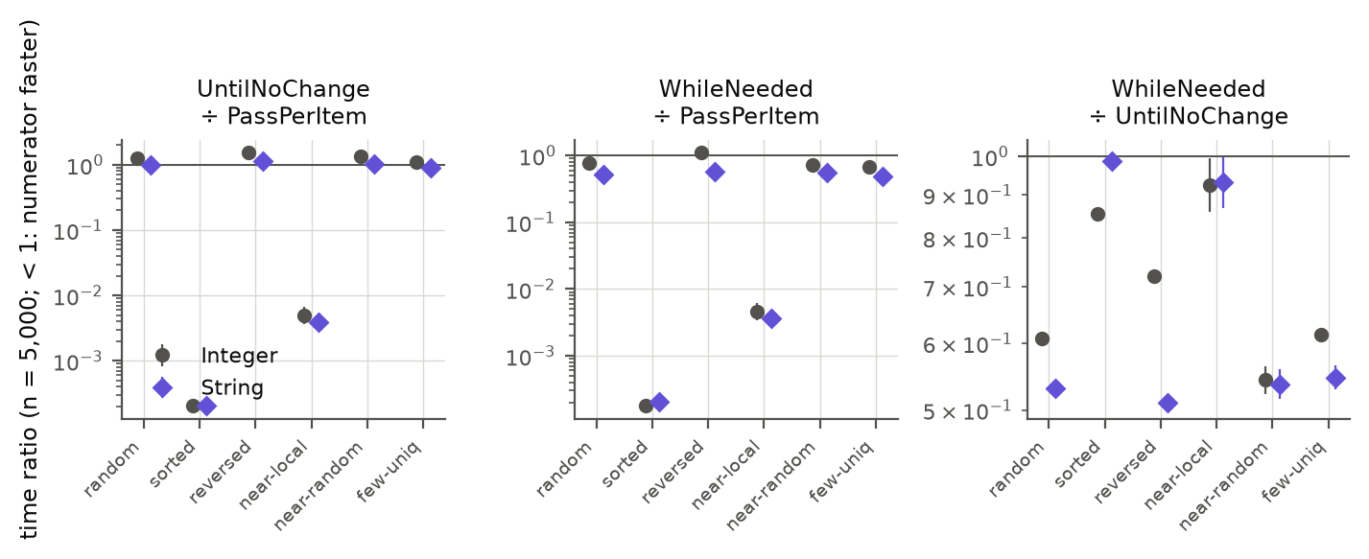
Figure 10. Time ratios at n = 5 000 for Integer and String elements (log axis; below 1 means the numerator is faster; bars are 95 % CIs).

E.2 Garbage collector, JDK version and JIT profile
Figure 11 compares the three pairwise ratios at n = 5 000 across all settings, and Table 11 the slowdown relative to the best algorithm in each cell. Two observations stand out. First, the ranking for random, sorted, nearly sorted and few-unique inputs is similar in all settings: WhileNeeded fastest, UntilNoChange slowest on random-like data, PassPerItem catastrophically slow on sorted and locally disturbed data (exceptions: with the polluted JIT profile UntilNoChange is as fast as PassPerItem on random input and 7 % faster than WhileNeeded on sorted input). Second, the single anomaly of the main experiment – WhileNeeded about 10 % slower than PassPerItem on reversed input – occurs in the main setting (JDK 26.0.1 on this Mac), in its repeat run and with the Parallel collector. With G1 (the JVM default), on JDK 8, 17, 21 and 25.0.5, and on the two other machines of Appendix E.9, WhileNeeded is as fast as or faster than PassPerItem on reversed input. (The row "JDK 26 (repeat run)" was planned as JDK 25, but the Homebrew package openjdk@25 on this Mac turned out to contain JDK 26.0.1, as the environment file of that run shows; it is therefore a repeat of the main setting, and it reproduces the main result. A real JDK 25 was measured afterwards, row "JDK 25 (this Mac)", see Appendix E.9.)
Table 11. Per setting (n ∈ {1 000, 5 000, 10 000}; polluted: {1 000, 5 000}): in how many (order, size) cells each algorithm is fastest, and the worst slowdown relative to the best algorithm in a cell. The row "main" uses only forks 0–4 of the main data, as the other rows have 5 forks (the main-laptop row of the table in E.9 uses all 10 forks).
Setting | PassPerItem fastest | UntilNoChange fastest | WhileNeeded fastest | WhileNeeded worst slowdown | UntilNoChange worst slowdown | PassPerItem worst slowdown
main: JDK 26, SerialGC | 3/18 | 0/18 | 15/18 | 1.10 | 1.96 | 13 124
JDK 26, G1 GC | 0/18 | 0/18 | 18/18 | 1.00 | 1.91 | 10 650
JDK 26, ParallelGC | 3/18 | 0/18 | 15/18 | 1.10 | 1.85 | 8 392
JDK 26 (repeat run) | 3/18 | 0/18 | 15/18 | 1.10 | 1.94 | 12 985
JDK 25 (this Mac) | 0/18 | 1/18 | 17/18 | 1.00 | 2.21 | 10 869
JDK 21 | 0/18 | 0/18 | 18/18 | 1.00 | 1.84 | 9 915
JDK 17 | 0/18 | 0/18 | 18/18 | 1.00 | 1.90 | 9 938
JDK 8 | 0/18 | 0/18 | 18/18 | 1.00 | 1.91 | 12 996
JDK 26, polluted JIT profile | 0/10 | 2/10 | 8/10 | 1.10 | 1.82 | 5 176
2nd M3 Pro, JDK 25.0.1 | 0/18 | 1/18 | 17/18 | 1.01 | 2.50 | 10 832
Ryzen 5 5600 (x86), JDK 26 | 0/18 | 0/18 | 18/18 | 1.00 | 2.44 | 11 568

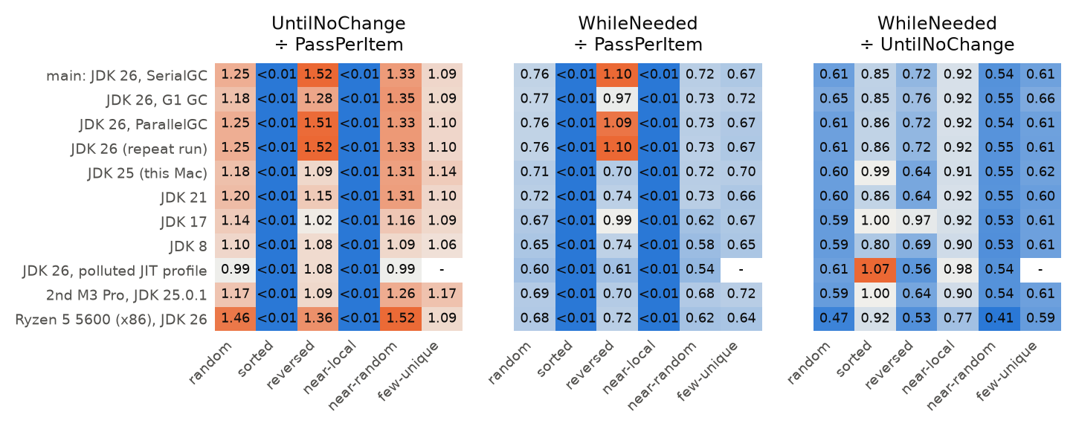
Figure 11. Time ratios at n = 5 000 for different garbage collectors, JDK versions and a polluted JIT profile (same data in every setting).
The absolute speed does depend on the setting, but only little for GC and JDK version (geometric mean within about ±10 % of the main setting, the extremes are the reversed-input cells, where WhileNeeded needs only 0.64–0.67 of its main-setting time on JDK 21 and 25.0.5, i.e. the anomaly itself). The polluted JIT profile is different: when the JIT compiler has already seen other element types, every algorithm becomes slower by a factor of 2.8–3.7 (geometric mean over cells), because the call to compareTo can no longer be inlined. The ranking nevertheless survives: WhileNeeded is fastest in 8 of 10 polluted cells and never more than 10 % behind the best; it needs about 40 % less time than PassPerItem on random and reversed input – so with a polluted profile the reversed-input disadvantage of the main experiment is gone. The absolute times in Section 3 are therefore a best case for a clean JVM, not a prediction for a real application.
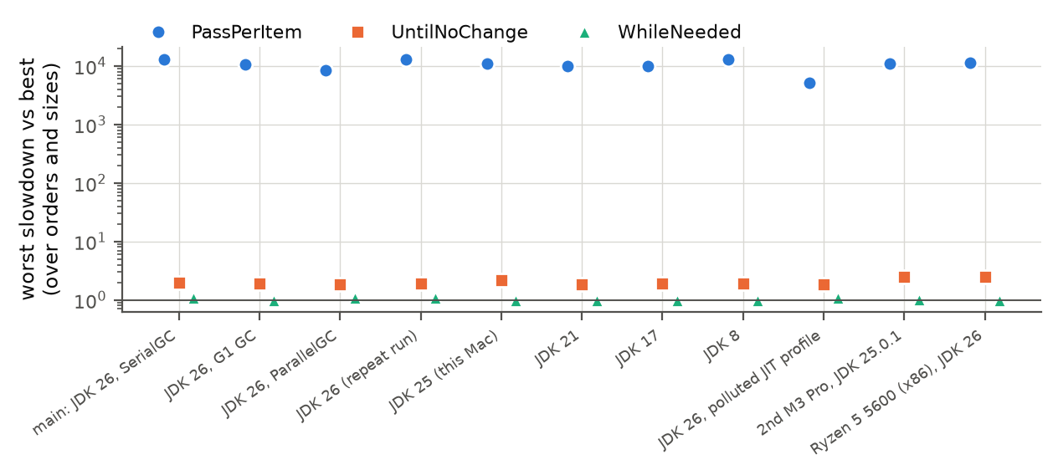
Figure 12. Worst slowdown relative to the best algorithm in a cell, per setting (log axis).

E.3 Tiny arrays (n = 2 … 50)
For arrays of 50 or fewer elements one sort takes between a few nanoseconds (sorted input) and about 3 µs. On sorted input the early-stopping algorithms are clearly faster (WhileNeeded needs 0.17× the time of PassPerItem at n = 10 and 0.022× at n = 50). On the other input orders the differences are small in absolute terms (best-to-worst spread up to about 1–2 µs): WhileNeeded is the fastest algorithm in 77 % of all 48 (order, size) combinations, UntilNoChange and PassPerItem win the rest, all of them at n ≤ 20 (at n = 50 WhileNeeded wins all 8 input orders). The fastest algorithm is on median 1.25× faster than the second fastest (range 1.01–1.92×), and the confidence intervals in Figure 13 overlap for many of these cells.
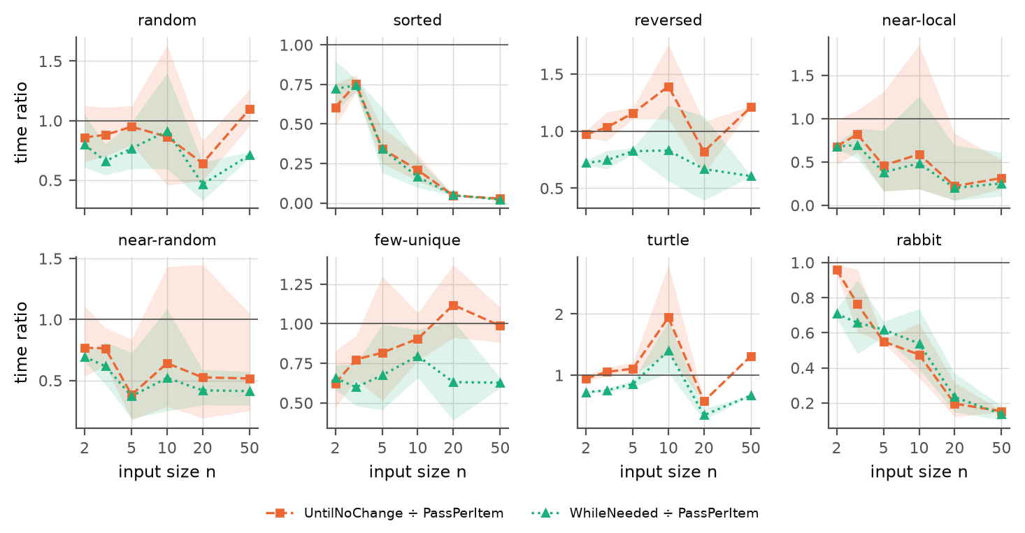
Figure 13. Time of UntilNoChange and WhileNeeded relative to PassPerItem for very small arrays (bands: 95 % CI).

E.4 Other classic input shapes
The five additional shapes are turtle (a small element at the very end, which bubble sort moves left only one position per pass), rabbit (a large element at the start, which moves to the end in one pass), a sorted array with a random 10 % tail, an organ pipe and a sawtooth. For n = 5 000: WhileNeeded needs 0.67× the time of PassPerItem on the turtle, 0.52× on sorted + tail, 0.52× on the organ pipe and 0.55× on the sawtooth, and is about as fast as UntilNoChange on the rabbit (both ≈ 1000× faster than PassPerItem). UntilNoChange is up to 1.32× slower than PassPerItem on the turtle. WhileNeeded is the fastest algorithm in 13 of 15 shape/size cells and never more than 0.8 % slower than the best.
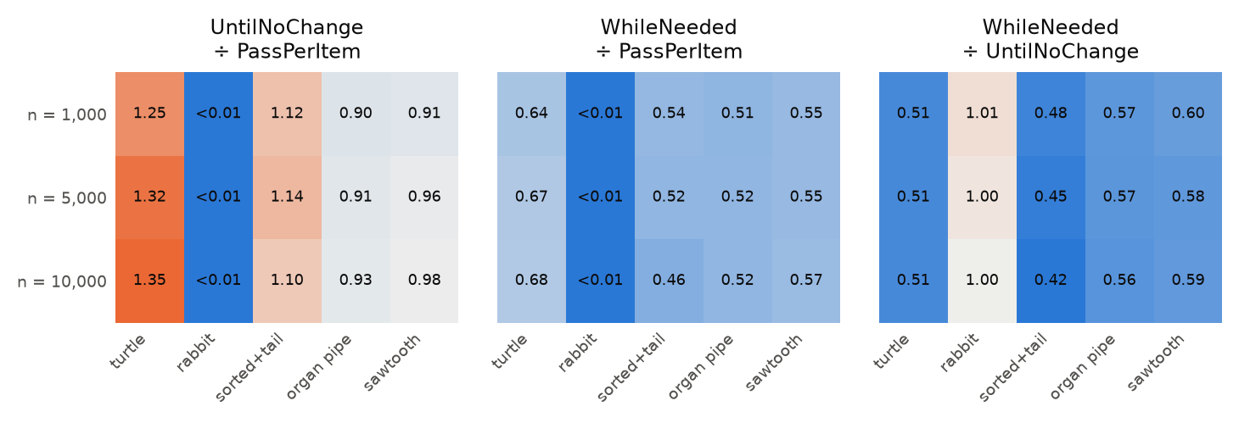
Figure 14. Time ratios for the additional input shapes.

E.5 Cold start
A program that sorts only a handful of times never reaches the optimised code that the main experiment measures. We timed the first 50 calls in 30 fresh JVMs per condition. Figure 15 shows that the very first call of PassPerItem on random input takes 8.6× the time of calls 20 and later for n = 100, 12× for n = 1 000 and 1.2× for n = 10 000 (the code is interpreted at first and then compiled in stages), and that for n = 100 and 1 000 the time stops falling after 10–20 calls. For n = 100 this plateau (42 µs) is still 8.2× the steady-state time of the main experiment (5.2 µs in the steady-state re-measurement): a fresh JVM does not reach the steady state within 50 calls. In the cold phase the ranking is similar: for random input WhileNeeded is fastest in all 12 of 12 checkpoints (first call, first 5 calls, first 20 calls). On reversed input, PassPerItem becomes slightly faster for n ≥ 1 000 after about 5 calls, as in the main experiment; on sorted input the early-stopping algorithms need only 0.2–36 % of PassPerItem's time, depending on n and the number of calls.
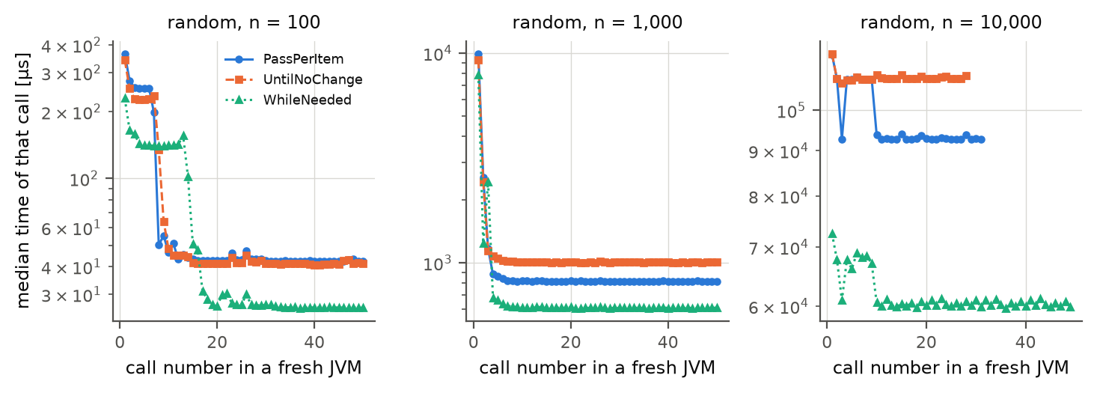
Figure 15. Median time of the k-th call in a fresh JVM (random input), n = 100, 1 000 and 10 000 (log axis; 30 JVMs per curve).

E.6 Cross-check with JMH
JMH is the standard Java micro-benchmark harness. We ran it on a subset (random, reversed and nearly-local input; n = 5 000 and 20 000; 3 JVMs, 10 iterations of 1 s, one sort per invocation) and compared the ratios between the algorithms with ours. For random and reversed input the ratios agree to within 1.2 % (ratio of ratios 0.990–1.012), so our hand-written harness does not bias the comparison. On nearly-local input the ratios are very small (≈0.003) and differ by up to a factor 1.8, probably because JMH sorts a single fixed random input whereas we draw a new one per fork (we did not test this); the conclusion (hundreds of times faster than PassPerItem) is the same.

E.7 Scaling, replication, load and correctness
Scaling. Fitting time = c · n^k to the 10 sizes between 1 000 and 40 000 (10 sizes × 5 forks = 50 points, treated as independent, so the intervals are optimistic) gives exponents k (95 % CI) on random input of 2.12 (2.11–2.14) for PassPerItem, 2.08 (2.06–2.09) for UntilNoChange and 2.02 (2.01–2.03) for WhileNeeded; on sorted input 2.01 (1.98–2.04) for PassPerItem and 1.01 (1.00–1.01) and 1.01 (1.00–1.01) for the two others. The growth is quadratic (PassPerItem steeper than 2 on average; the local exponents of Table 12 show that this is a localised steepening between n ≈ 5 000 and 15 000, not a constant excess) and linear, respectively.
Table 12. Local scaling exponents on random input (slope of log time against log n between consecutive sizes; medians over 5 forks).
From n | To n | PassPerItem | UntilNoChange | WhileNeeded
200 | 500 | 1.98 | 1.99 | 2.03
500 | 1 000 | 2.01 | 2.06 | 2.05
1 000 | 2 000 | 2.00 | 1.99 | 2.02
2 000 | 3 000 | 1.98 | 2.01 | 2.00
3 000 | 5 000 | 1.97 | 1.98 | 1.97
5 000 | 7 500 | 2.10 | 1.99 | 1.87
7 500 | 10 000 | 2.37 | 2.25 | 2.17
10 000 | 15 000 | 2.40 | 2.22 | 2.09
15 000 | 20 000 | 2.11 | 2.14 | 2.05
20 000 | 30 000 | 2.06 | 2.09 | 2.08
30 000 | 40 000 | 2.05 | 2.07 | 2.06

Replication. The complete main design was repeated with a different random seed (new data, new JVMs). Of the 108 cell medians, 94 % differ from the main data by less than 5 % and 98 % by less than 10 %. For n ≥ 1 000 the median absolute difference is 0.1 % and the largest 18.9 %. The Spearman correlation of the cell medians is 0.9999. The only larger deviations are the two nearly-sorted cells with local swaps at n = 5 000 (−16 % and −19 %), which have the highest between-data variation (see Appendix F).
Load. Under load the median slowdown is 1.057× (range 1.048–1.364). From idle to load, the median CV between forks rises from 1.3 % to 1.7 %, and the median relative IQR of the batches from 1.6 % to 25.7 %. Six busy background processes thus slow the sorts by about 6 % on average but make single batches far more variable, which confirms that benchmarks must be run on an otherwise idle machine – as ours was, apart from the logged short tests (Section 2.4).
Correctness. The three sorters passed all 20 139 checks: every permutation of up to 7 elements, 600 random arrays against Arrays.sort, all 11 input shapes, stability, and in-place behaviour (results/correctness/correctness.txt). All timed results in every experiment were also verified to be sorted. The timing comparison therefore compares correct, equivalent sorters.

E.8 JIT compiler level
HotSpot first interprets the bytecode, then compiles hot loops with the fast C1 compiler and finally with the optimising C2 compiler. We repeated the experiment with C2 switched off (C1 only) and with the compiler switched off entirely (interpreter only), at n = 2 000 (the interpreter is too slow for larger sizes). With the default JIT, UntilNoChange needs 1.22× the time of PassPerItem on random input and WhileNeeded 1.09× on reversed input. With only C1 these ratios are 1.05 and 0.64, and in the interpreter 0.98 and 0.56. Without C2 the running time simply follows the number of comparisons: WhileNeeded needs 0.53–0.66× the time of PassPerItem on random and reversed input, UntilNoChange equals PassPerItem. The two main surprises of the main experiment (UntilNoChange slower than PassPerItem on random input; WhileNeeded slower than PassPerItem on reversed input) need the C2 compiler: without it the ranking simply follows the comparison counts. We did not inspect the code that C2 generates, so why it produces these two effects remains open.
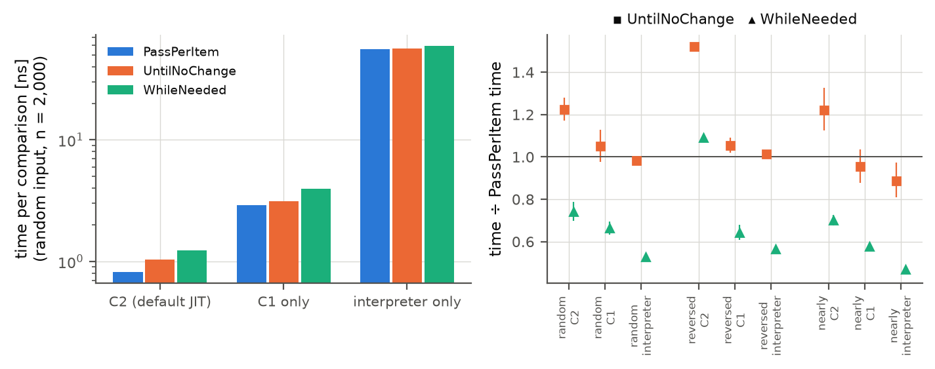
Figure 16. Effect of the JIT compiler level at n = 2 000: time per comparison on random input (left) and time ratios to PassPerItem (right) with the default JIT, with C1 only and in the interpreter.

E.9 Other computers
All measurements so far come from one laptop. To test whether the conclusions depend on it, we repeated the reduced design (6 input orders × n = 1 000, 5 000, 10 000 × 3 algorithms × 5 forks × 20 batches; same code, seed and JVM flags) on an x86 desktop (AMD Ryzen 5 5600, 6 cores, 16 GB RAM, Windows 11) and on a second Apple M3 Pro laptop (macOS 27). Table 13 lists the runs next to the matching data from the main laptop. The JDK of each run is taken from its environment record. The main-laptop JDK 17 row comes from the JDK follow-up, which uses ExtendedWorker with the same procedure. Machine and JDK are not fully crossed, and the JDK builds differ slightly, so this is a descriptive check.
Table 13. The same design on different computers and JDKs (n ∈ {1 000, 5 000, 10 000}, 18 cells). Slowdown is relative to the fastest algorithm per cell. Spread: median of (max − min) / median of the batches of one fork.
Run | JDK | Forks | WhileNeeded fastest | Worst slowdown: WhileNeeded | Worst slowdown: UntilNoChange | Worst slowdown: PassPerItem | PassPerItem ÷ WhileNeeded, reversed, n = 5 000 | Spread within a fork
M3 Pro laptop 1, JDK 26 (main) | 26.0.1 | 10 | 15/18 | 1.10 | 1.96 | 13 130 | 0.91 [0.91, 0.91] | 4.9 %
M3 Pro laptop 1, JDK 17 | 17.0.19 | 5 | 18/18 | 1.00 | 1.90 | 9 938 | 1.01 [0.98, 1.04] | 2.7 %
M3 Pro laptop 1, JDK 25 | 25.0.5 | 5 | 17/18 | 1.00 | 2.21 | 10 869 | 1.43 [1.42, 1.44] | 5.1 %
M3 Pro laptop 2, JDK 25 | 25.0.1 | 5 | 17/18 | 1.01 | 2.50 | 10 832 | 1.44 [1.39, 1.48] | 6.2 %
Ryzen 5 5600, JDK 26 | 26.0.2.1 | 5 | 18/18 | 1.00 | 2.44 | 11 568 | 1.38 [1.37, 1.39] | 10.2 %
Ryzen 5 5600, JDK 17 | 17.0.21 | 5 | 17/18 | 1.06 | 2.22 | 11 517 | 1.56 [1.47, 1.67] | 28.2 %

The recommendation holds. On the x86 desktop with JDK 26, WhileNeeded is the fastest algorithm in 18/18 cells, while UntilNoChange is up to 2.44× and PassPerItem up to 11 568× slower than the best. Absolute times differ, but the largest effect (early stopping on sorted input) has the same order of magnitude in every run.
The reversed-input anomaly does not transfer. With the same major JDK version, PassPerItem needs 1.38× the time of WhileNeeded on the desktop (n = 5 000, CI 1.37–1.39), against 0.91× (CI 0.909–0.913) on the main laptop: the direction is reversed. So the anomaly does not follow from JDK 26 alone. With one computer per architecture and no inspection of the machine code, we cannot attribute it to the CPU architecture itself (Figure 17).
Data quality. The desktop is noisier than the main laptop: the spread within a fork is 10.2 % against 4.9 %. Reversed input has two outlier JVMs: at n = 1 000 one fork has a ratio of 1.01, and at n = 10 000 one has 3.38, so the geometric means at these sizes have wide intervals while the median fork ratios stay near 1.38–1.39. The JDK 17 desktop run is weaker still (28.2 % spread, power state not recorded); its decimal commas (old code on a non-English locale) were repaired during analysis, leaving the raw file as measured. The measurements of these runs are in Appendix D.
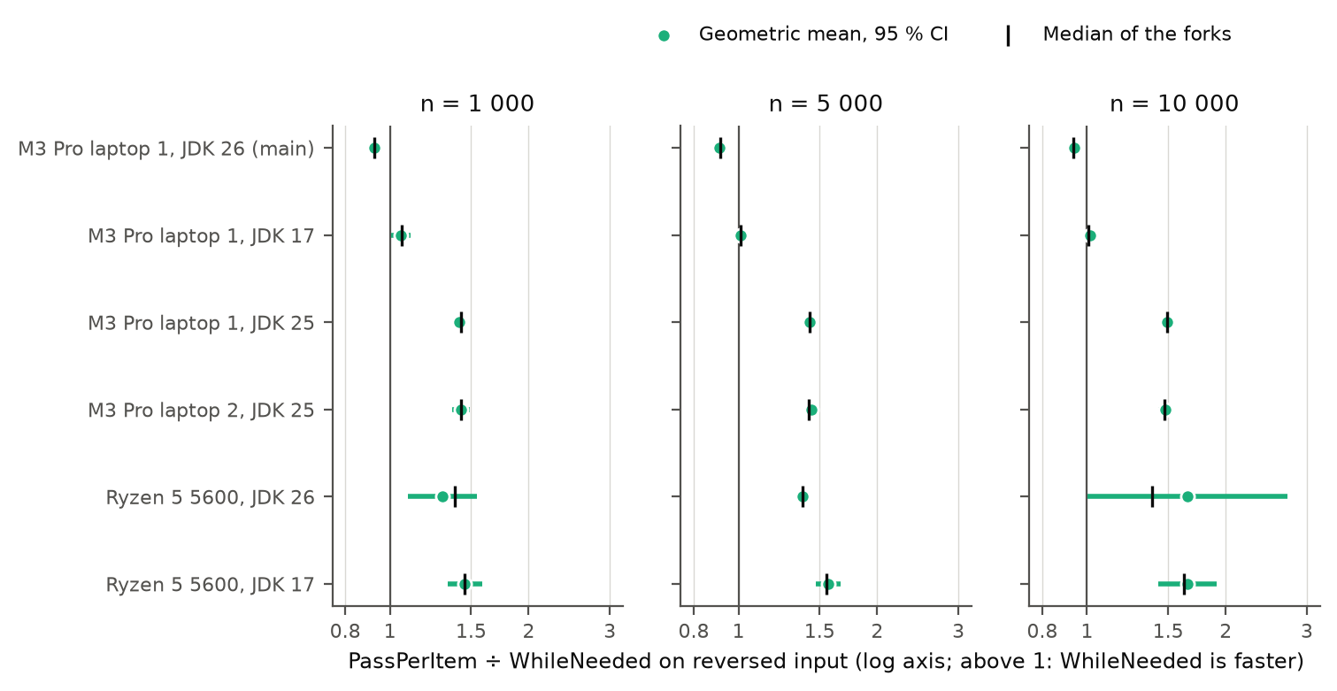
Figure 17. PassPerItem ÷ WhileNeeded on reversed input per computer and JDK: geometric mean of the paired forks with 95 % CI, and the median of the per-fork ratios.
JDK 25 on the main laptop. To separate the Java version from the hardware we also measured a real JDK 25 on the main laptop, with the same macOS and JVM flags but with Temurin instead of Homebrew, ExtendedWorker and 5 forks × 20 batches (the ExtendedWorker repeat on JDK 26.0.1 reproduces the main result): WhileNeeded ÷ PassPerItem on reversed input at n = 5 000 is 0.70 (CI 0.697–0.704) with Temurin 25.0.5, i.e. WhileNeeded is clearly faster and the anomaly is absent. On the same laptop the anomaly therefore disappears when the JDK changes from the Homebrew OpenJDK 26.0.1 of the main experiment to Temurin 25.0.5, so the laptop alone does not cause it; the desktop result (Temurin 26.0.2.1) shows that the major version 26 alone does not cause it either. Our data cannot tell whether it is a property of JDK 26.0.1, of this Homebrew build, or of JDK 26 combined with the M3 Pro: we have no run of JDK 26.0.1 on x86 or of JDK 26.0.2.1 on the M3 Pro. Vendor (Temurin instead of Homebrew) and power state are therefore confounded with the Java version. This JDK 25 run was made with the laptop on battery power (39 % at the start, 33 % at the end), unlike the main run; its spread within a fork (5.1 %) is similar to the main run (4.9 %). The Homebrew package openjdk@25 had also been used for the first attempt, which silently ran JDK 26.0.1 (Appendix E.2).

F. Re-measurement of uncertain conditions
The pre-registered rule (Section 2.4) flagged 10 of the 30 (order, size ≥ 1 000) groups as uncertain. These were measured again with 20 additional forks per algorithm (fork ids 10–29), so that they now have 30 forks (900 batches per cell), and we report the pooled data next to the main data. Table 14 lists the groups and why they were flagged.
Table 14. Groups re-measured with 20 additional forks.
Input order | n | Reason(s) for re-measuring (rule in REMEASURE_RULE.md)
nearly sorted (local swaps) | 1 000 | UntilNoChange: CV 20.1 %; UntilNoChange: CI half-width 14.3 %; WhileNeeded: CV 13.5 %; WhileNeeded: CI half-width 9.6 %
nearly sorted (local swaps) | 2 000 | UntilNoChange: CV 19.7 %; UntilNoChange: CI half-width 14.1 %; WhileNeeded: CV 12.9 %; WhileNeeded: CI half-width 9.2 %
nearly sorted (local swaps) | 5 000 | UntilNoChange: CV 16.6 %; UntilNoChange: CI half-width 11.9 %; WhileNeeded: CV 16.2 %; WhileNeeded: CI half-width 11.6 %
nearly sorted (local swaps) | 10 000 | UntilNoChange: CV 22.6 %; UntilNoChange: CI half-width 16.2 %; WhileNeeded: CV 13.2 %; WhileNeeded: CI half-width 9.4 %
nearly sorted (local swaps) | 20 000 | UntilNoChange: CV 9.4 %; UntilNoChange: CI half-width 6.7 %; WhileNeeded: CV 9.7 %; WhileNeeded: CI half-width 6.9 %
nearly sorted (random swaps) | 1 000 | UntilNoChange: CV 8.1 %; UntilNoChange: CI half-width 5.8 %
nearly sorted (random swaps) | 2 000 | UntilNoChange: CI half-width 3.3 %
random | 10 000 | H2 inconclusive (UntilNoChange / PassPerItem within 0.85-1.15)
reversed | 20 000 | PassPerItem: CV 7.9 %; PassPerItem: CI half-width 5.7 %
sorted | 20 000 | UntilNoChange: CV 36.9 %; UntilNoChange: CI half-width 26.4 %; H6 inconclusive (WhileNeeded / UntilNoChange <= 1.05)

Effect on the hypothesis verdicts. After pooling, one hypothesis cell changes: H2, UntilNoChange / PassPerItem within 0.85-1.15, random n = 10000: inconclusive → falsified (1.161, CI 1.153–1.168). All other cells keep their verdict, so the main conclusions do not depend on the re-measurement. The overall verdicts remain: H1 and H4 supported; H2, H3, H5 and H6 falsified.
Why were the groups uncertain? There are two different reasons. (1) Nearly sorted with local swaps (all five sizes): here the between-fork variation (CV 10–23 %) is not measurement noise. Each fork uses a different random input (5 % of the elements displaced), and the running time of the early-stopping algorithms depends strongly on how far the most displaced element has to travel, i.e. on the data. The 30 forks give a better estimate of the distribution of running times over such inputs, but the spread remains. The pairwise ratios are paired by data set and stay tight. (2) Sorted input, n = 20 000, UntilNoChange: inside every JVM the time per sort changes from about 11.4 µs to about 5.7 µs after some of the timed batches (Section 3.7). The pooled split of 40 % of the forks at 5.7 µs and 60 % at 11.4 µs therefore only shows in which phase the median of 30 batches falls; it is not two kinds of JVMs. Because the switch happens at different batches, the confidence interval of this cell is wide and the hypothesis cell stays inconclusive in the all-batches analysis.
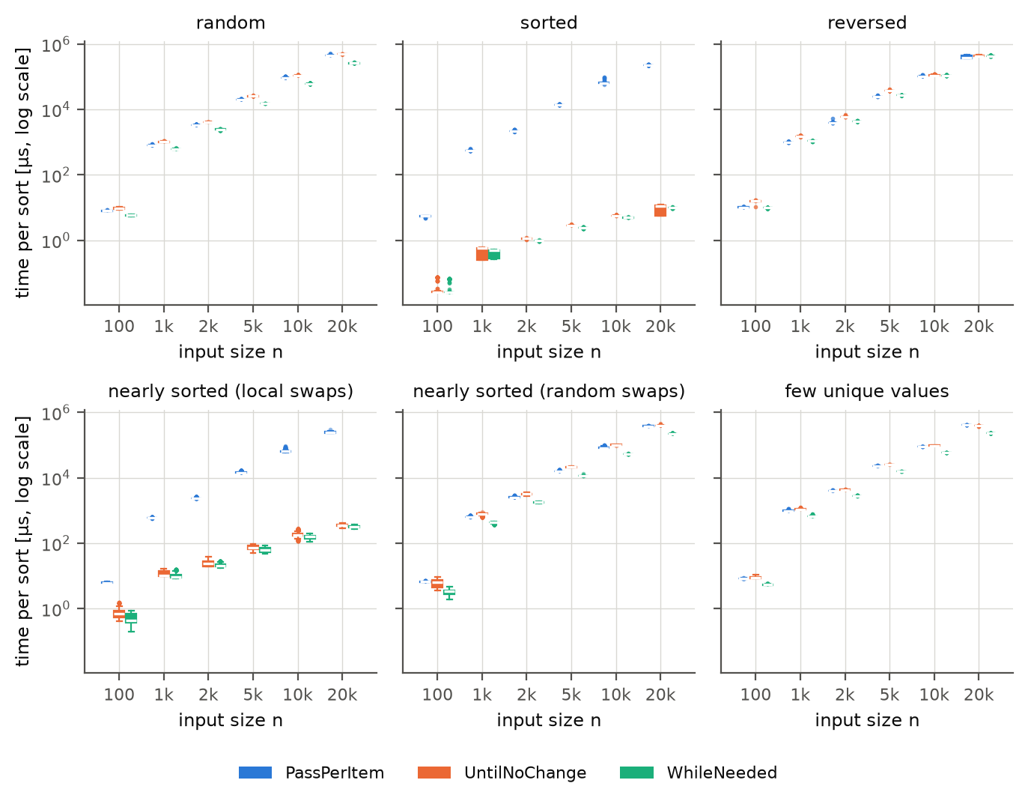
Figure 18. Pooled data (main + re-measurement): distribution of the time per sort for every input size (compare Figure 3).

